# Week1 Asking The "Right Questions"

## 1.1 Introduction

### Tips for Becoming a Data Analyst

1, Ask Questions, Nourish Curiosity, and Embrace the Unknown

to stay competitive, your skill set will need to be dynamic

2, Start Thinking about Everything You See as a Dependent or Independent Variable.

the dependent variable, because it is the phenomenon I am measuring and I'm most interested in

3, explore the advantages and disadvantages of continuous versus discrete variables

Bar graph vs. line graph

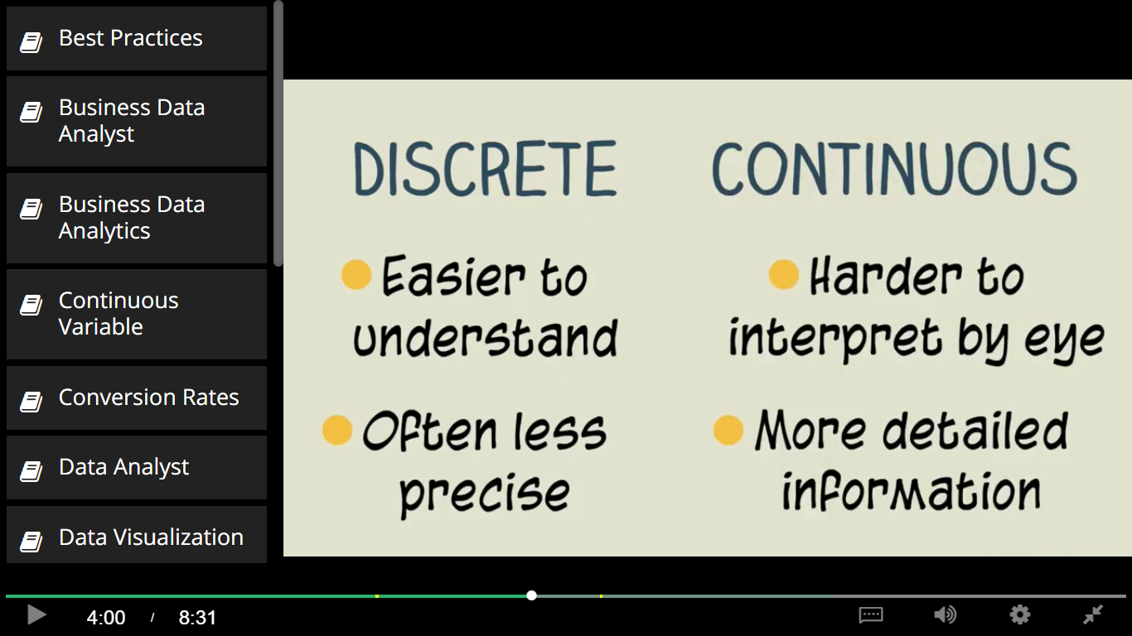

4, make sure you always listen, and contribute

5. Train your skepticism muscles

whenever somebody tells you something with extreme confidence, temper your expectations

 6, that's why you need to seek details

 7, Cherish Precision

8, which is the the best practices in data analytics are not necessarily the most common practices in data analytics

9. the expectations of your teammates and stakeholders matter

10. the ability to put yourself in other people's shoes

## 1.2 Asking the Right Questions

### S.M.A.R.T. Objectives

Figure out where all your stakeholders’ true motivations and financial interests lie. Remember, unfortunately, they may not always know where their motivations and financial interest lie. Even, if they think they know.

What problem is this business having that you are hoping to solve by developing this project?

Can you tell me more about how this problem is affecting the business?

What is your ideal outcome for this project?

Specific

Measurable

Attainable

Relevant

Time-bound

>> People aren't returning back to our site after they log in for the first time. I need you to tell us how to convert first time visitors to returning visitors.

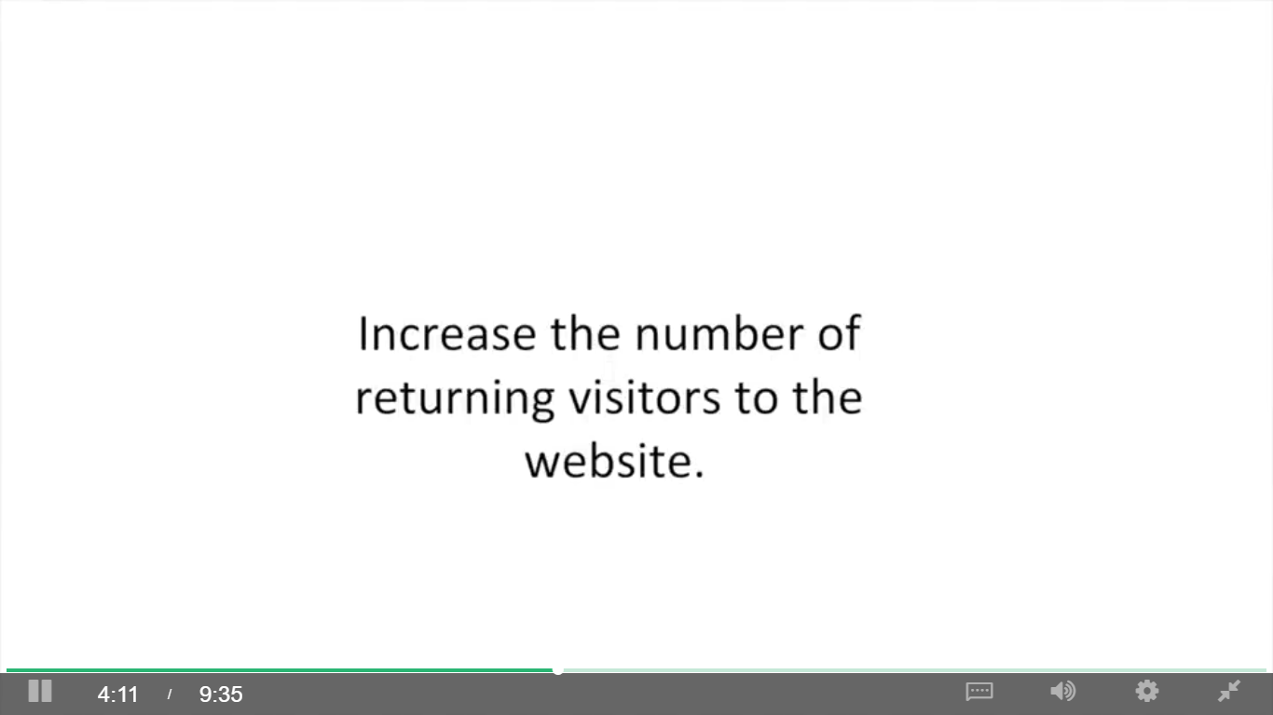

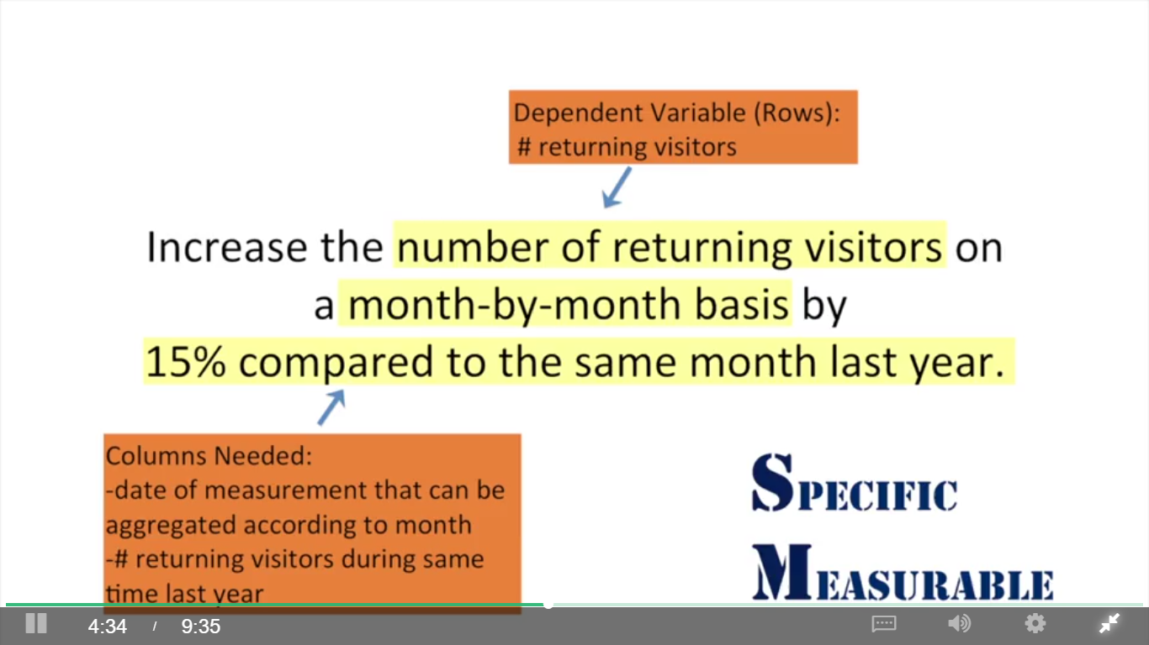

She was just making the assumption based on things she read. But the reasons profits were down was because customers weren't returning to the website. That's a good hypothesis, but in reality we have no idea whether the number of returning customers will be relevant to the drop in revenue. And if it turns out that the number of returning customers is not relevant to the drop in revenue, and your analysis is solely dedicated to the changing of the number of returning customers, your project manager and the rest of your stakeholders are not gonna be very happy.

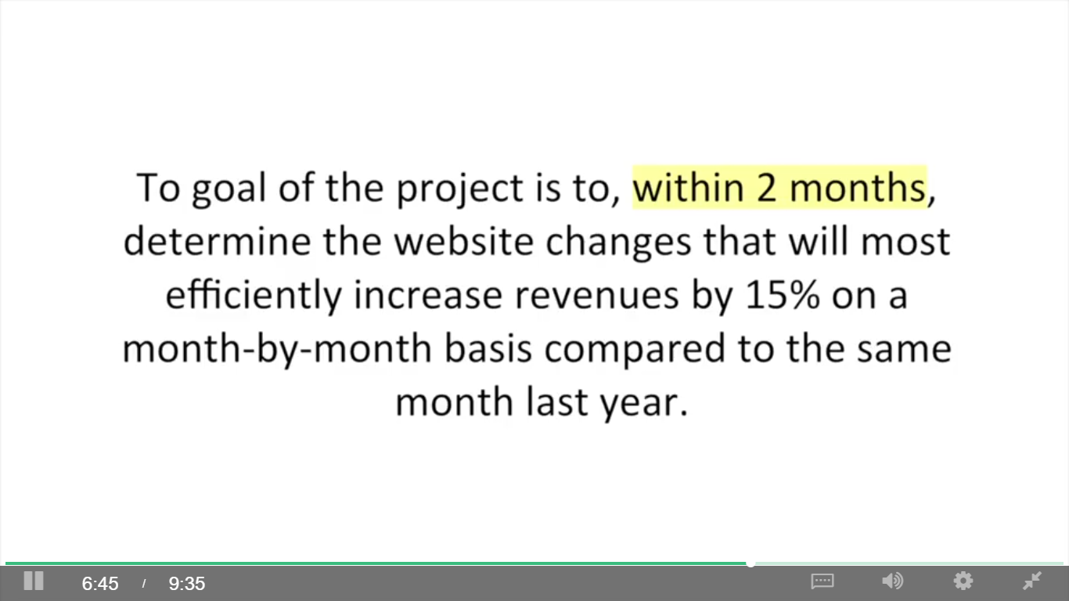

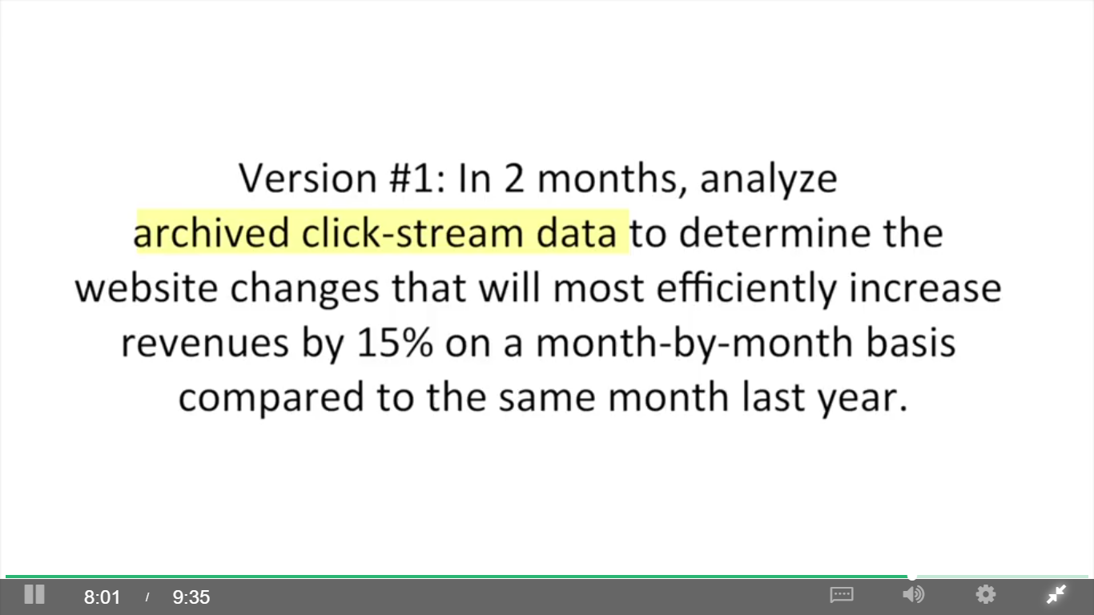

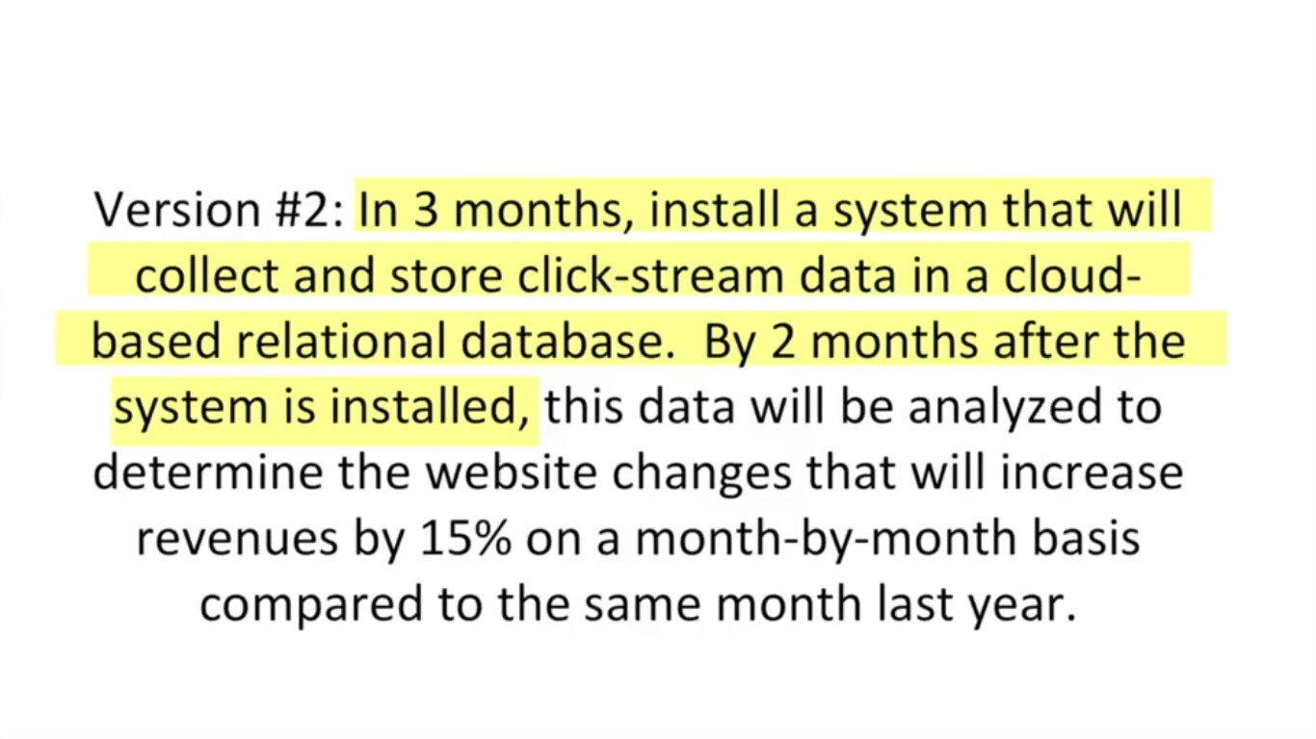

## 1.3 Your Stakeholders

### Listening to Stakeholders During Elicitation

Methods: in person meetings, focus groups, and emails

Goal

1. Identify your key stakeholders

2. Identify independent variables to test

what has been tried before and how did it turn out? What do you think might improve this business problem?

3. determine whether stakeholders agree about problem to be solved

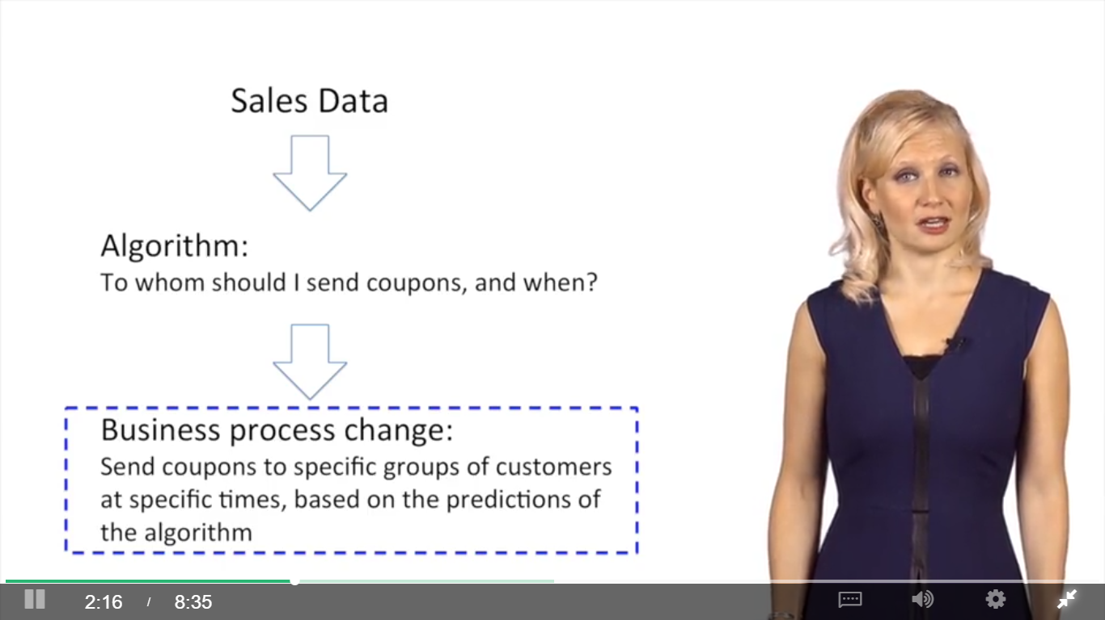

### Stakeholder Expectations Matter

Gartner:

Analytics continuum:

Descriptive: what happened or is happening

Diagnostic: why things are happening ( fraud detection)

Predictive: what is going to happen (forecasting)

Prescriptive: giving recommendations

Understand the cause of stakeholders’ reluctance

## 1.4 Structure Pyramid Analysis Plans

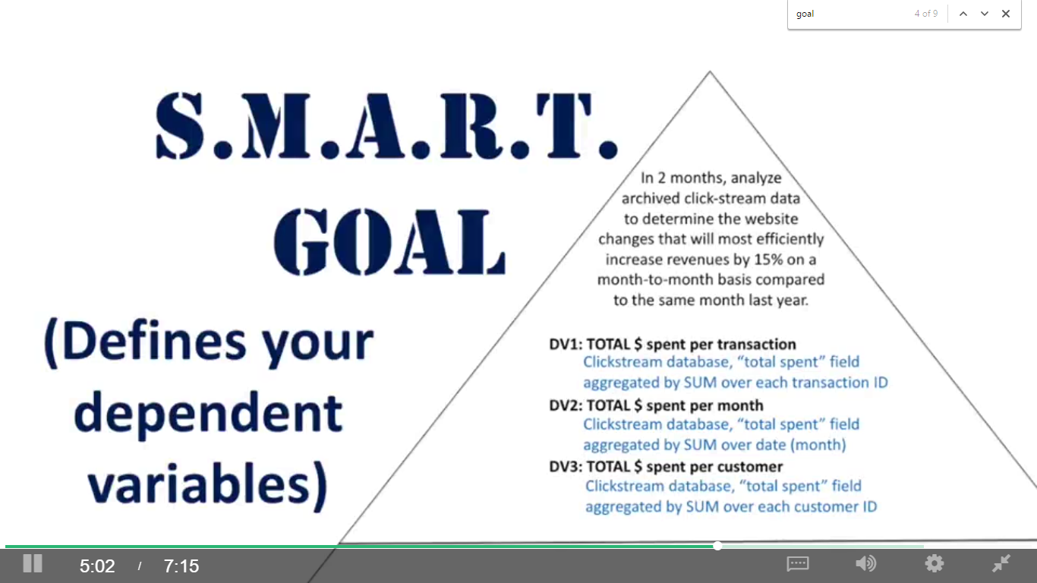

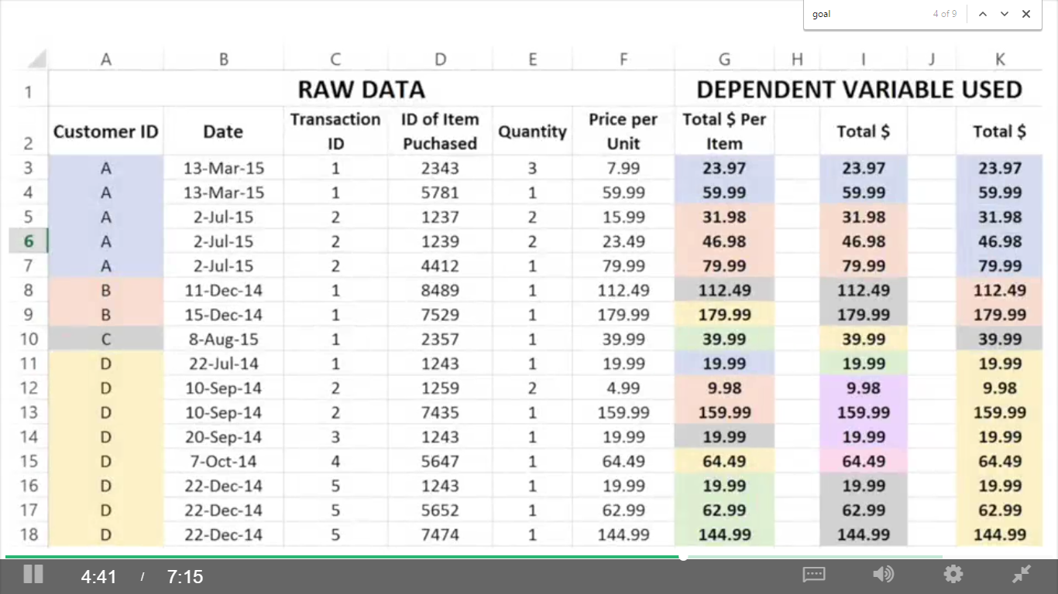

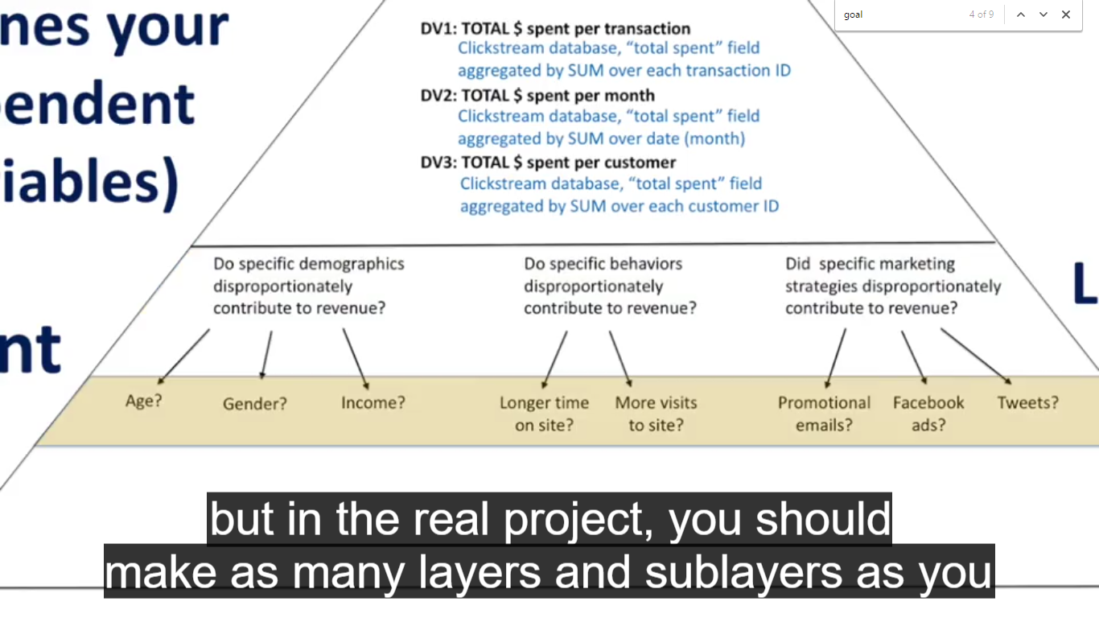

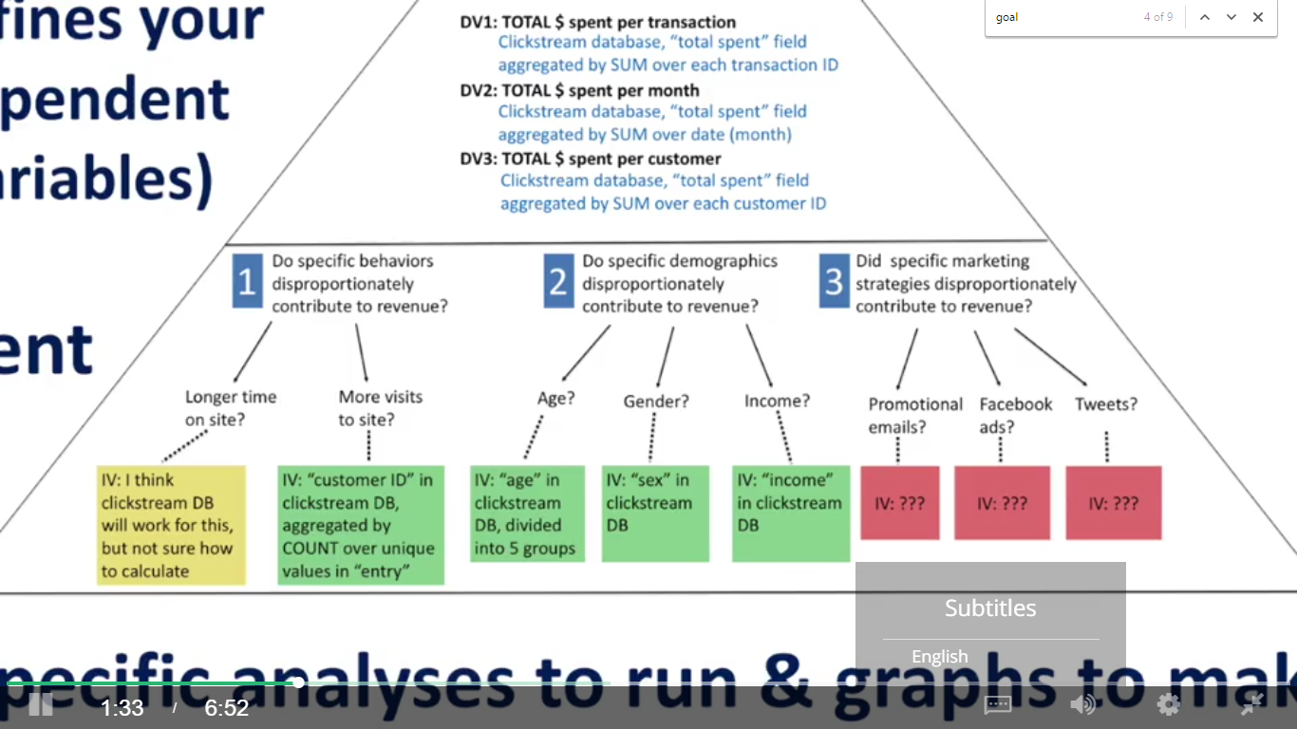

assign each category or subcategory a priority based on who suggested them, how much impact you suspect they could have, and how feasible you suspect they will be to assess.

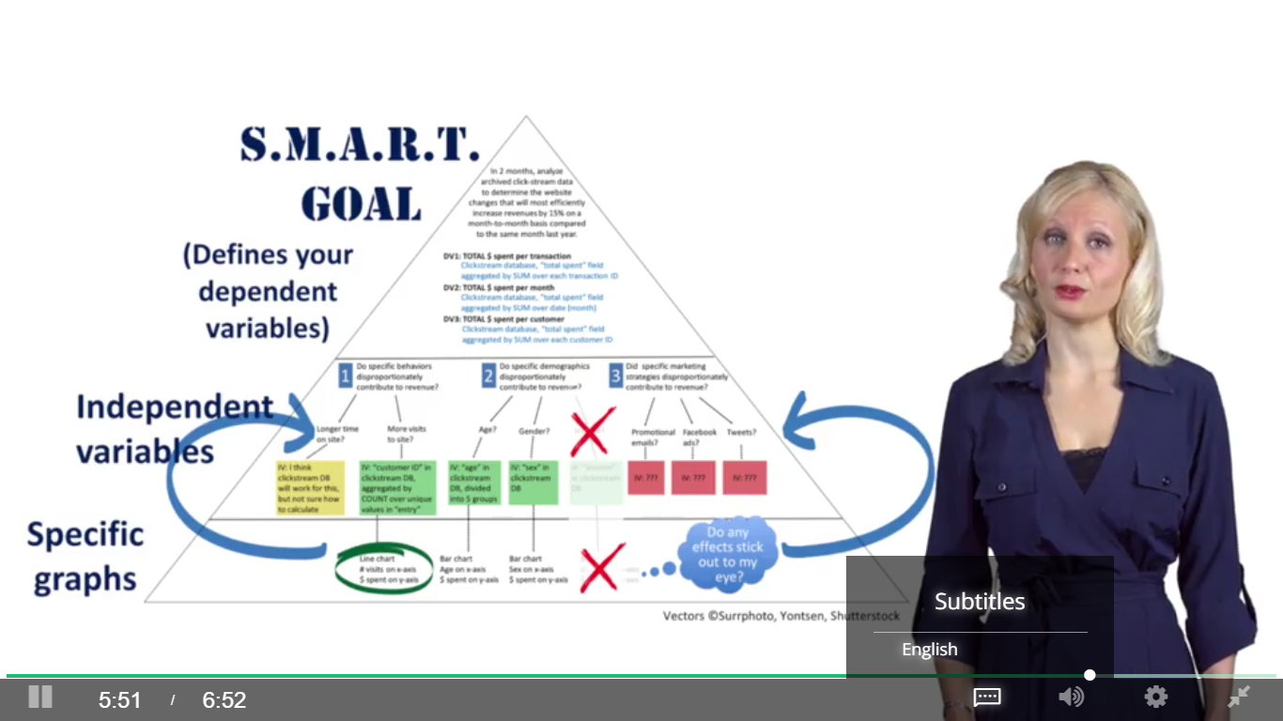

# Week2 Data Visualization with Tableau

## 2.1 Introduction

Why Tableau?

Connect databases and import data of big sizes

Easy to draw interactive dashboards

It will help you clean your data, find patterns in your data, test your hypothesis, and tell stories with your data

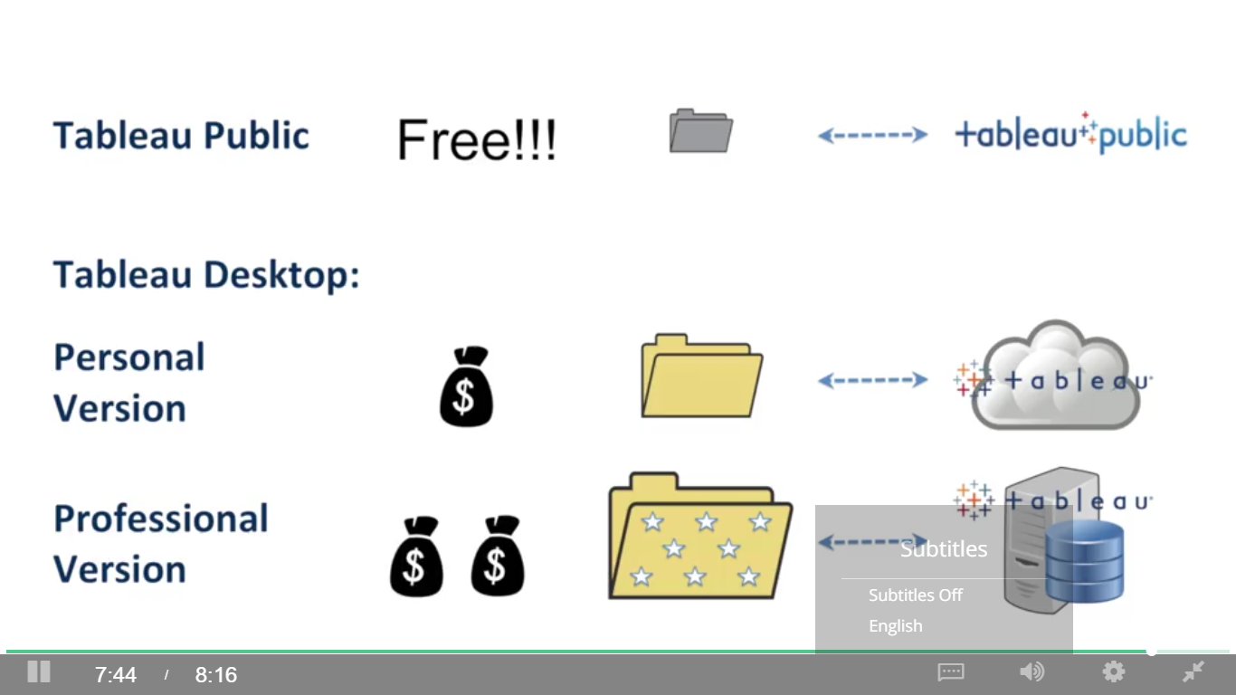

## 2.2 Using Tableau to Determine How Much You Can Make as a Data Analyst

## 2.3 Let’s Get Started!

### 2.3.1 Your First Graph

Measures: continuous variables (green)

Dimensions: discreet or categorical variables (blue)

Cards and shelves

Dependent variable = paid wage per year (rows)

Independent variable = job title subgroup (columns)

Change measure from sum to median

### 2.3.2 Formatting and Exporting

Columns and rows(double click), quick sort, swap(switch from vertical to horizontal bar chart)

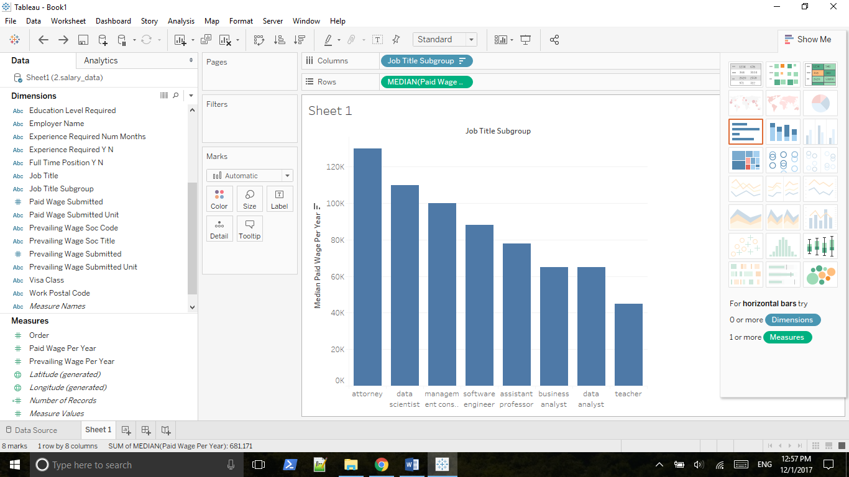

Save:

Worksheet => Export => Image

File => Print to PDF

File => Save as twb

### 2.3.3 Digging Deeper Using the Rows and Columns Shelves

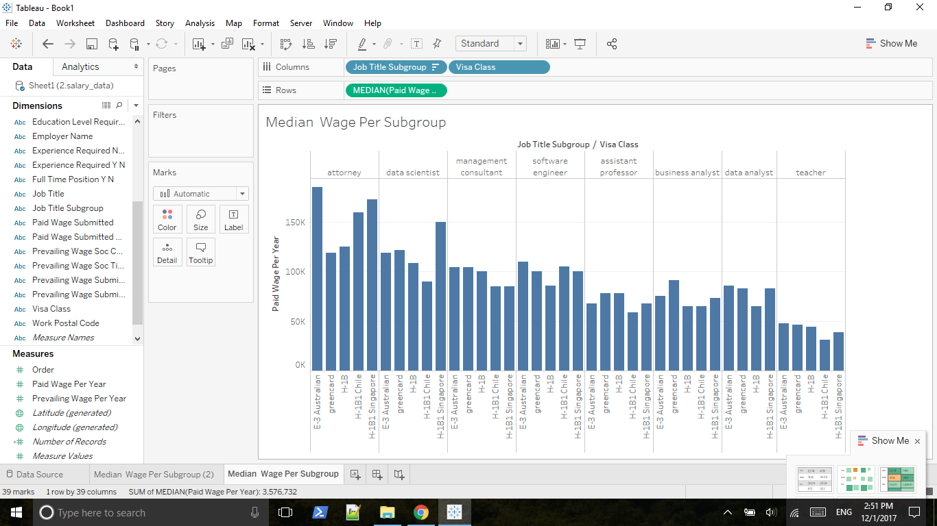

Change default aggregation to median

Right click bar and view data

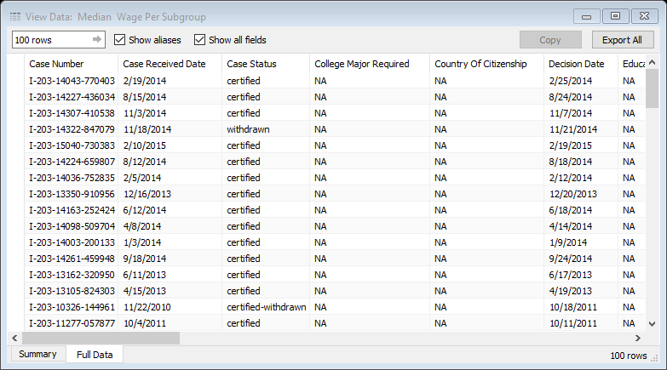

put number of rows behind paid wage

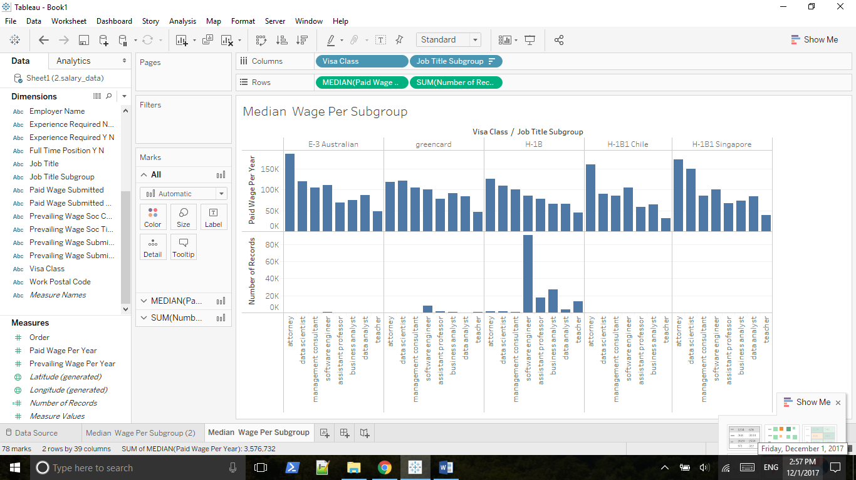

Number of records now showing on the tooltip

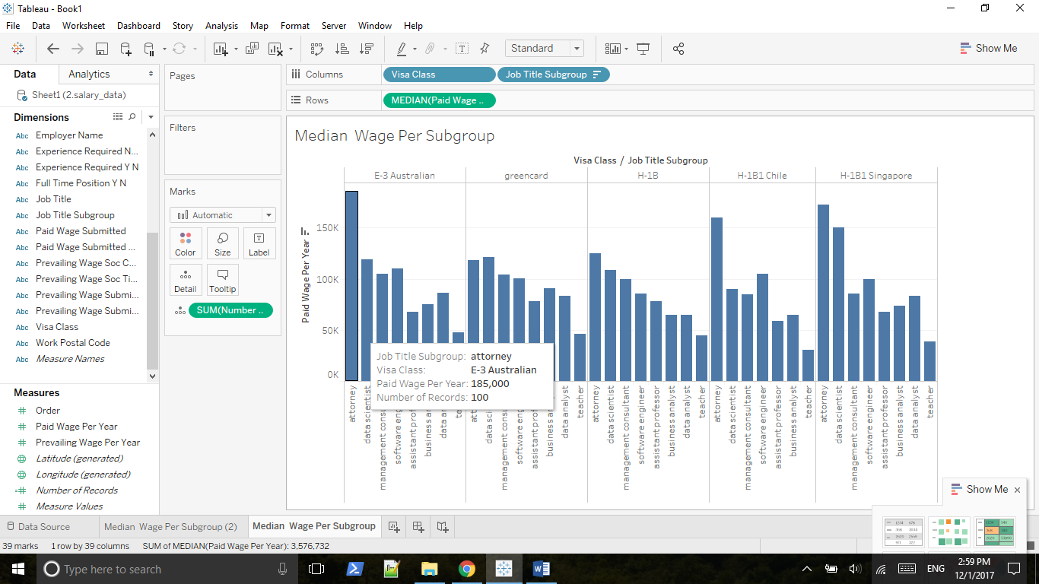

Another way of doing that: drag number of records on Detail button(Marks card)

Std. Dev (Pop) vs Std. Dev

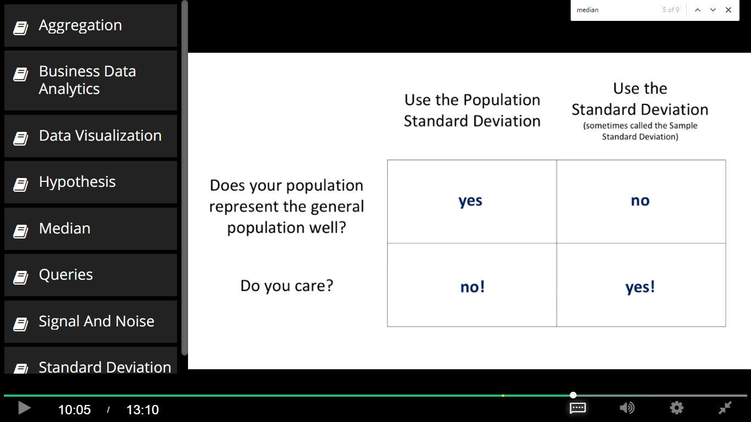

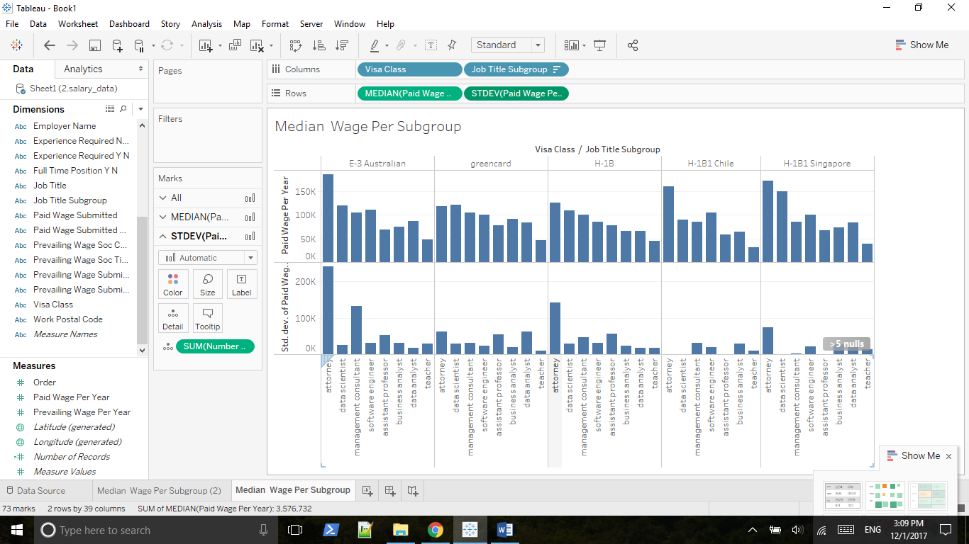

Press Shift key and move STDEV to the detail property.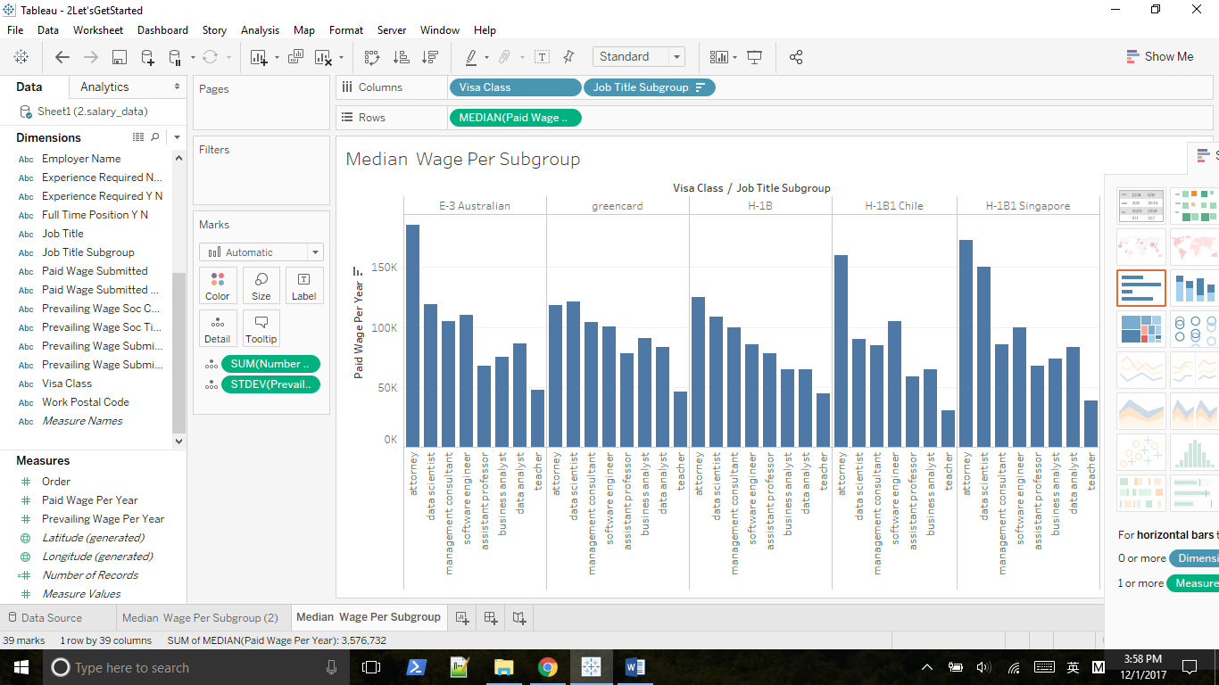

Huge std. dev implies the existence of outliers.

## 2.4 Working with the Marks Card

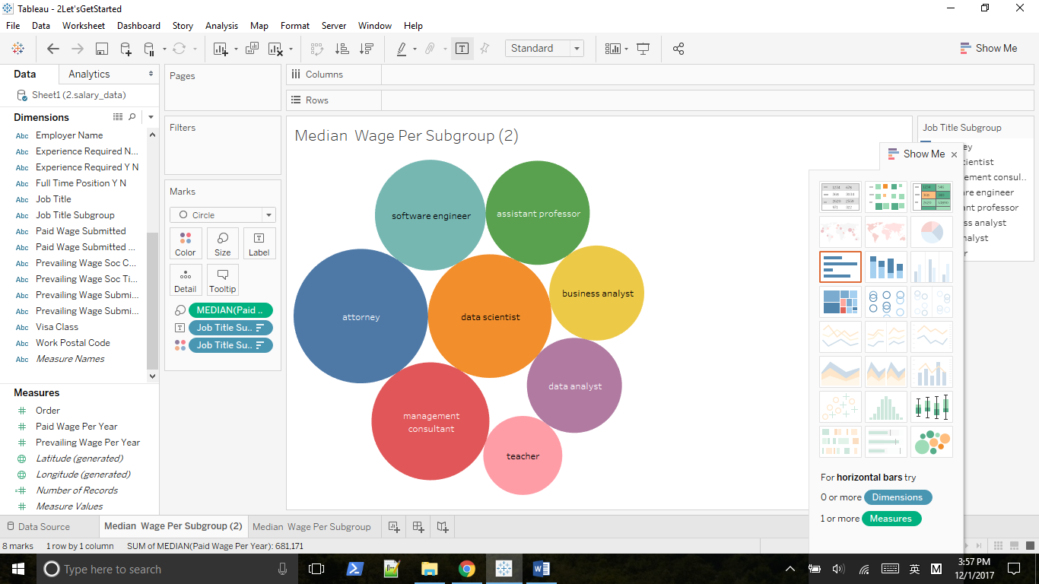

Move median on top of the Size property

Choose median paid wage as Rows, and drag job title subgroup on top of Color property

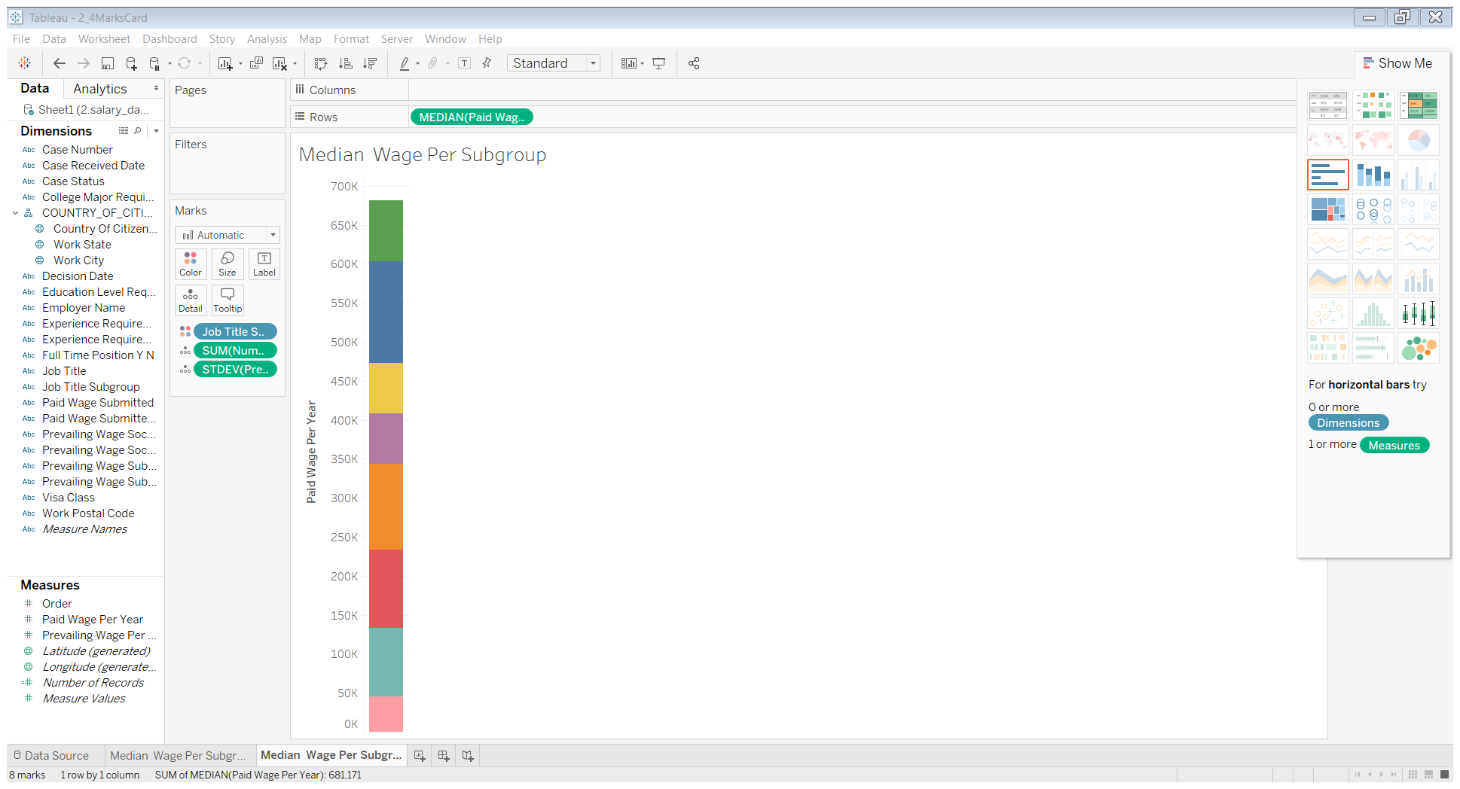

We need code by area, so move median paid wage on top of Size property

Then change Automatic to Circle

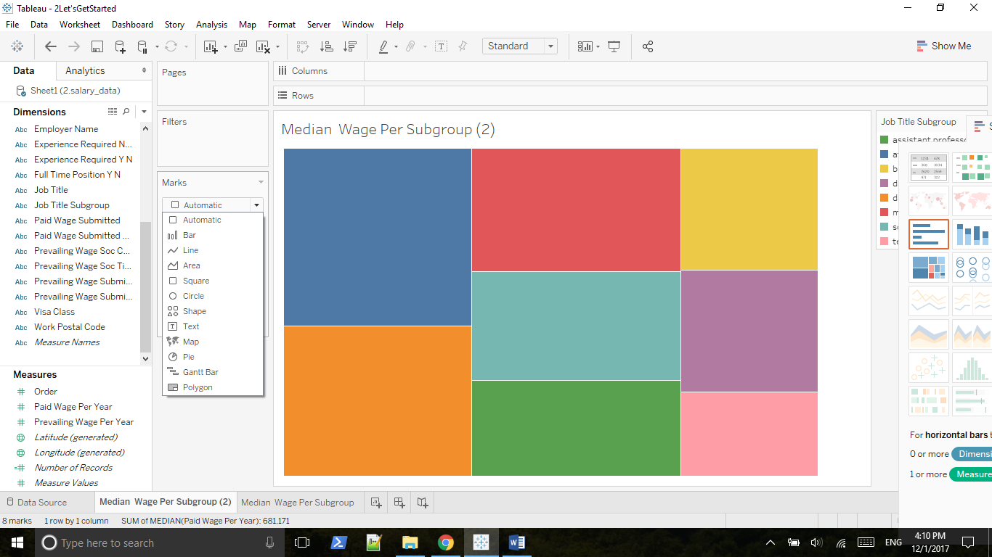

Move job title subgroup to the Label property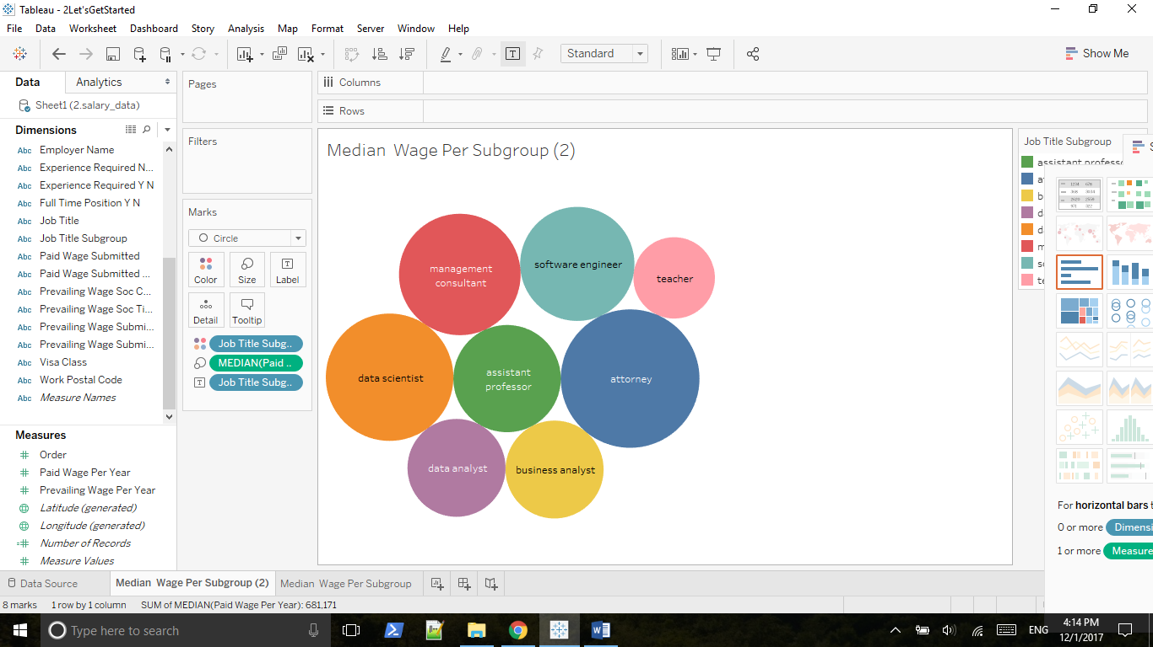

Move Visa Class to Columns

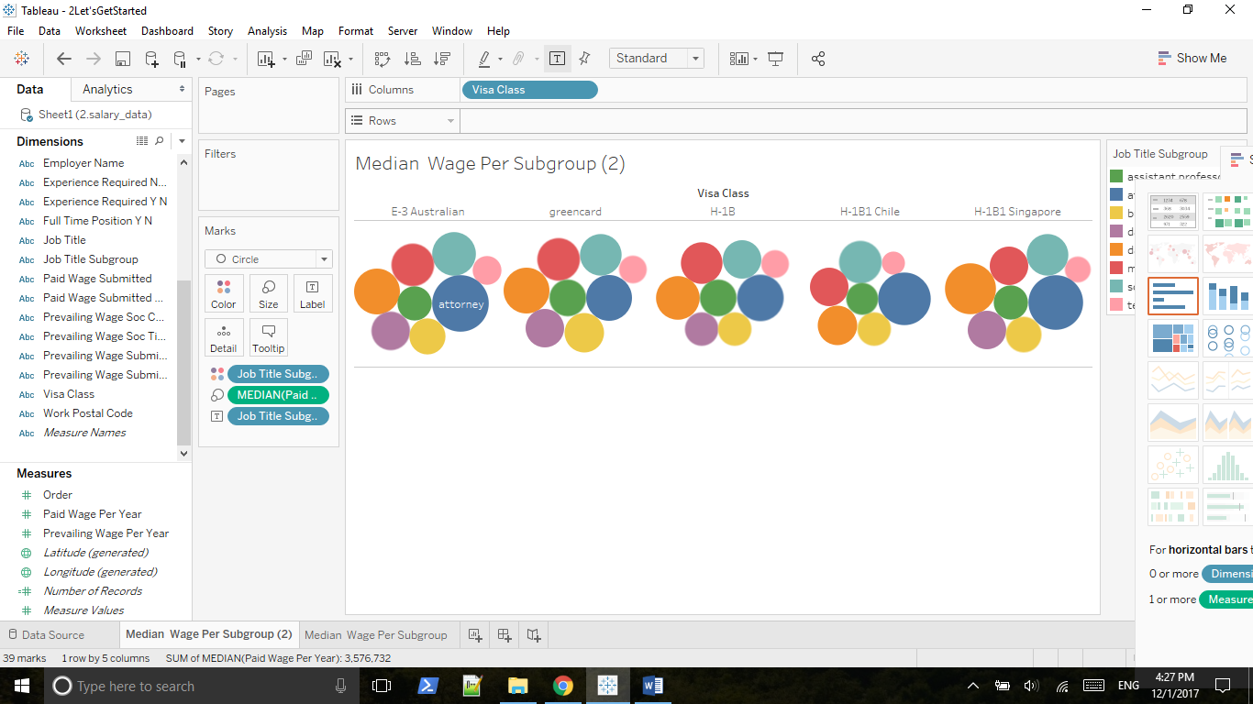

Coding visa class by color, coding the wage per year by size, coding the subgroup by label

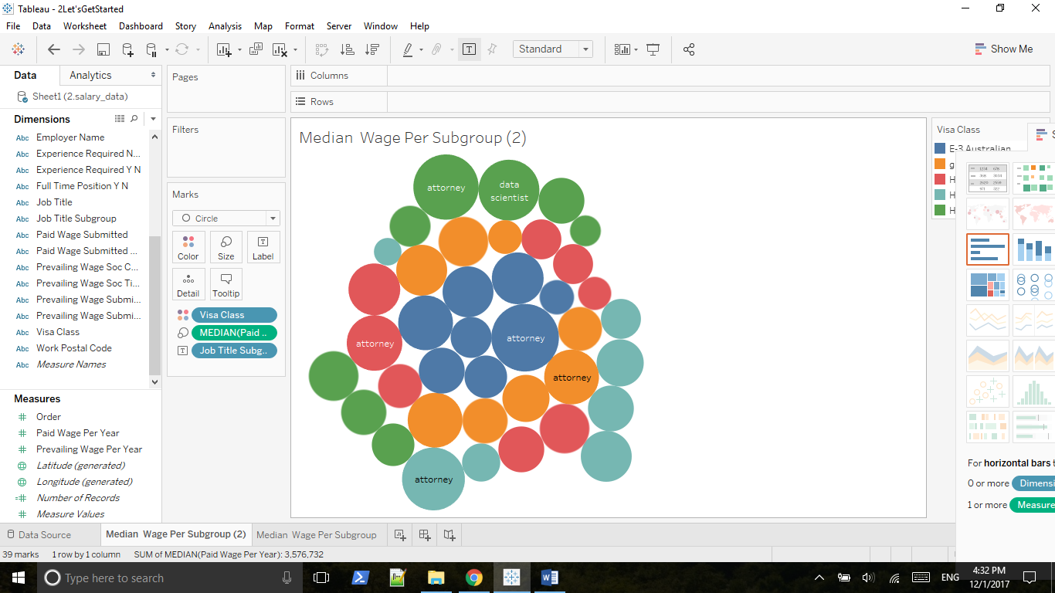

Make label => always show

Press shift together, coding subgroup by color and coding visa class by different shade of the color

Bad interpretation, since shade usually represents a continuous variable

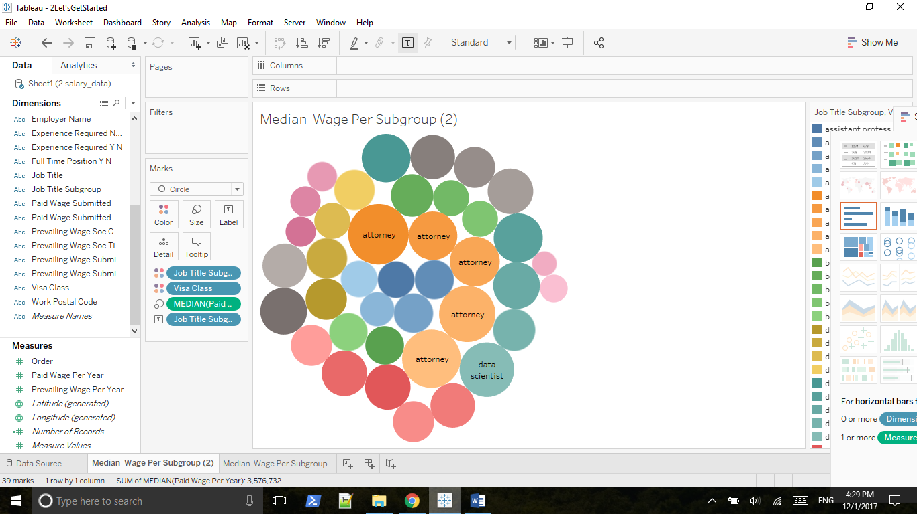

## 2.5 Outliers, Filtering and Groups

### 2.5.1 Removing Outliers Using Scatterplot and Filtering and Groups

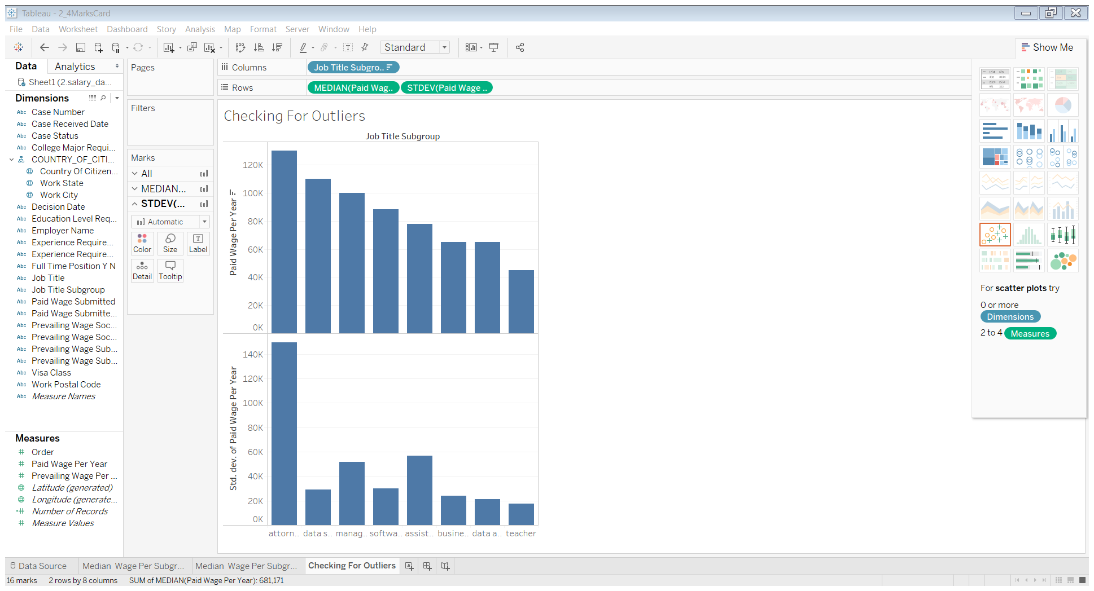

Hypothesis: Attorney group has outliers

Uncheck Analysis => Aggregate measures

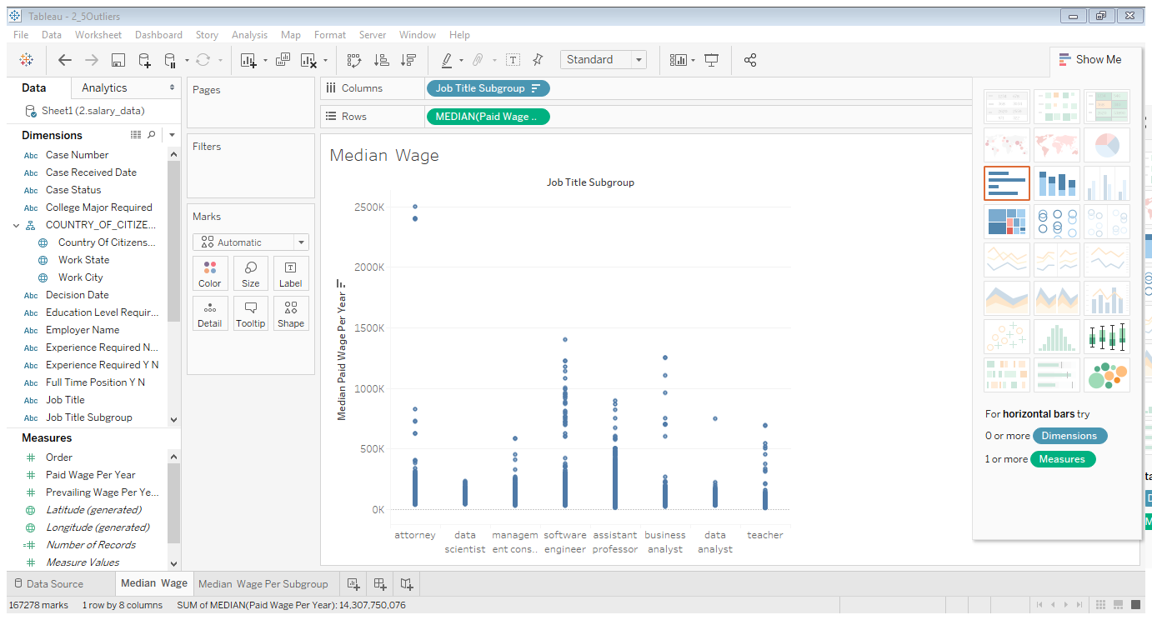

Use a filter, move paid wage per year on filter

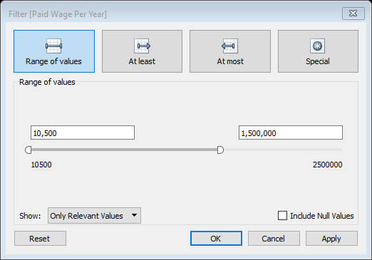

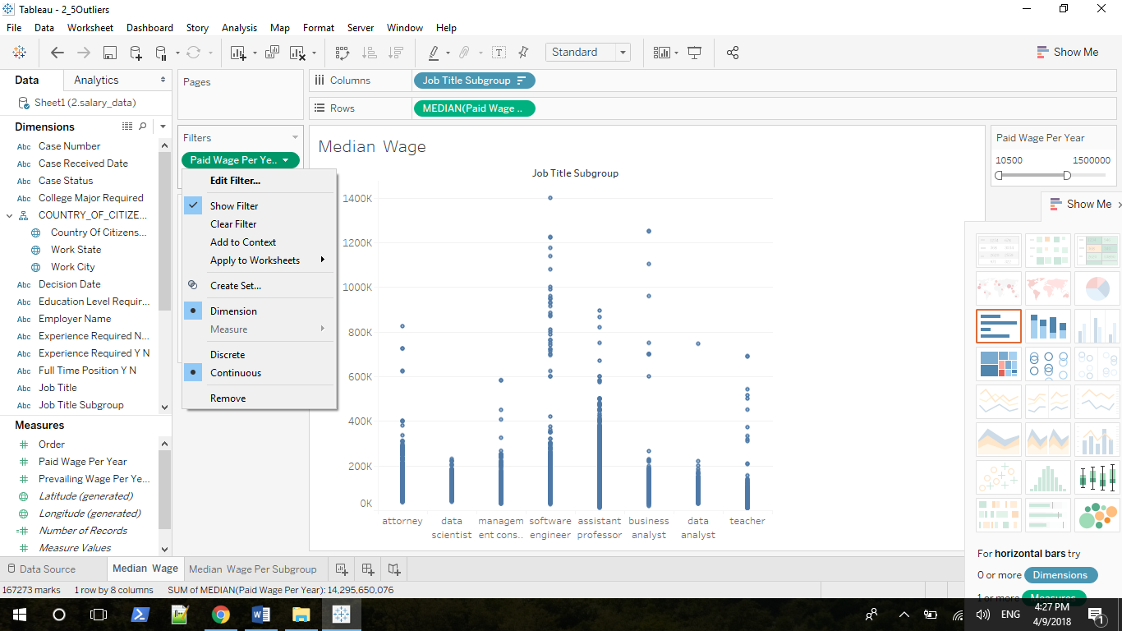

Create a group for outliers: drag case number on top of Detail property

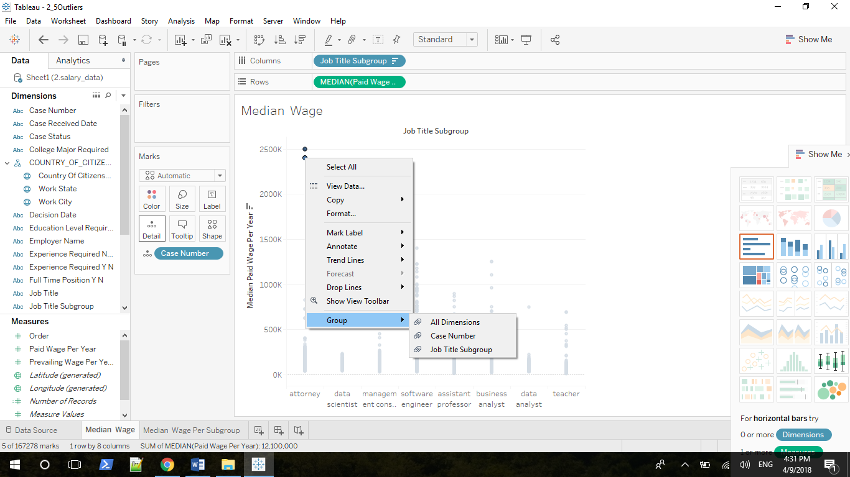

Group by Case Number

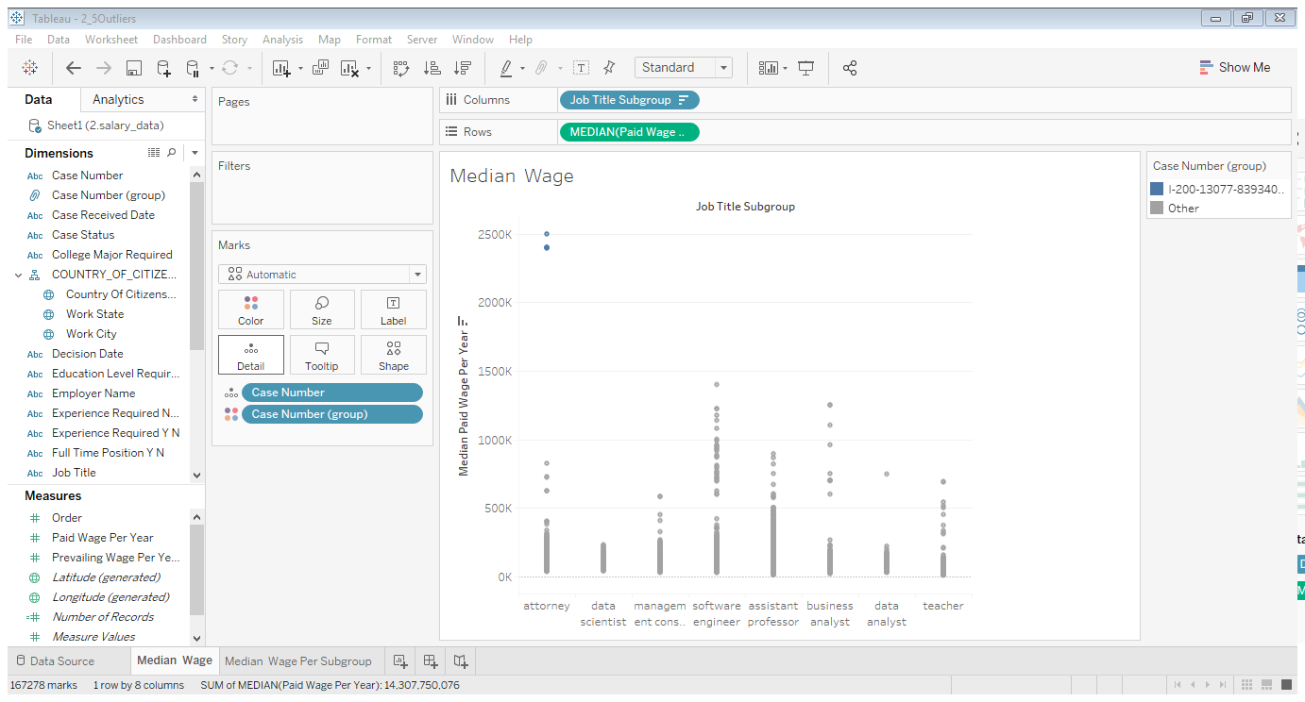

Now we have a Case Number (group), drag it on top of Filters and Show Filter, you can only see Other

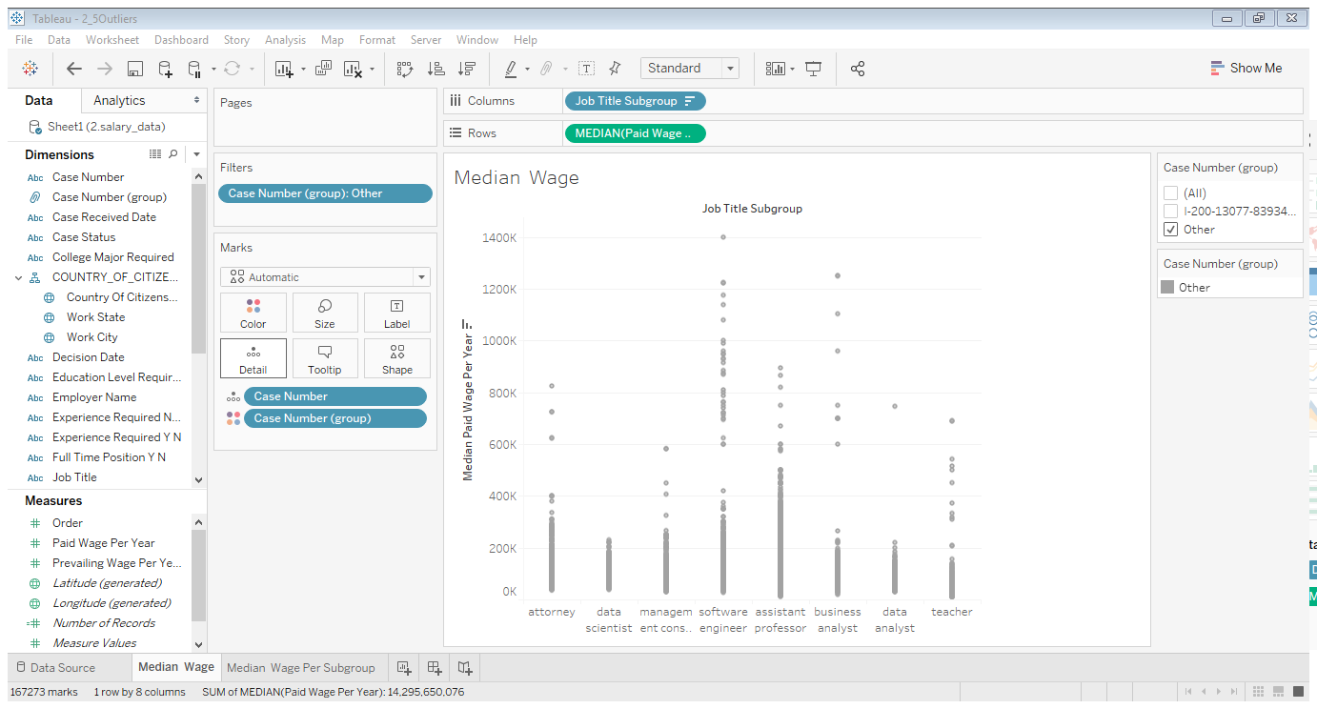

Drag Job Title Subgroup on top of Filters and choose Case Number (group) as Columns

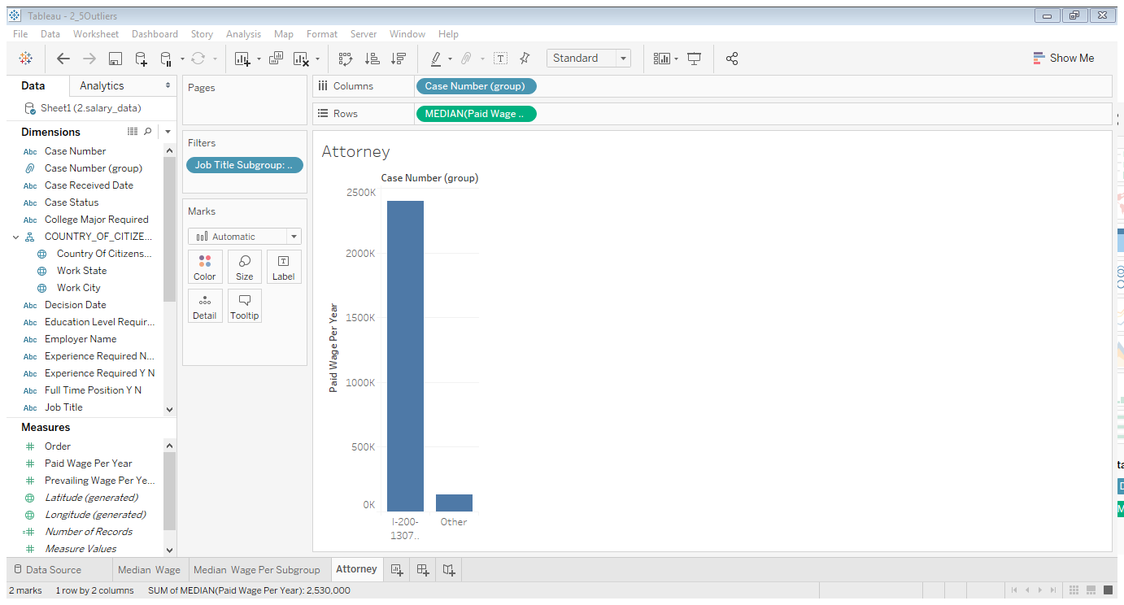

### 2.5.2 Analyzing Data-Related Salaries in Different States Using Filtering and Groups

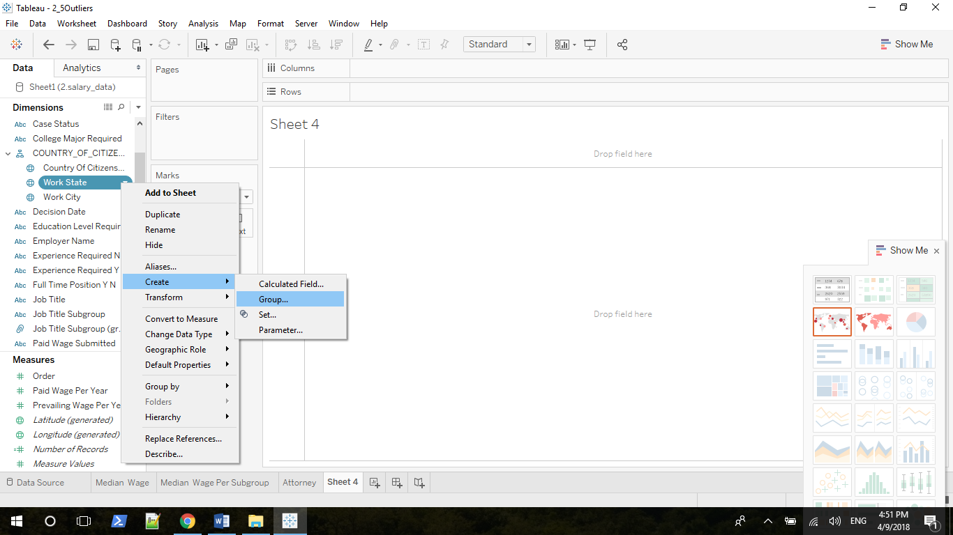

Choose Paid Wage Per Year as Rows, choose Job Title Subgroup and Work State (group) As Columns, and drag Job Title Subgroup on the Color property

You can edit group very easily

## 2.6 Line Graphs and Box Plots

### 2.6.1 When to Use Line Graphs

Line graphs are best for conveying two types of information:

1. How things change over time

2. How two continuous variables relate to one another

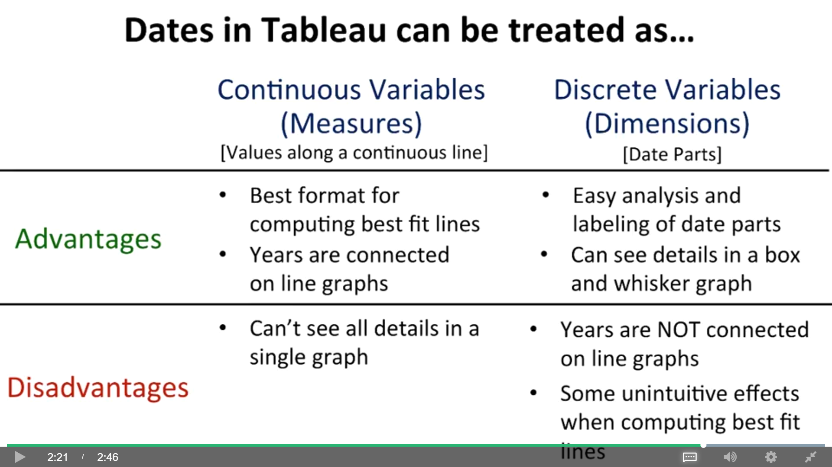

### 2.6.2 Dates as Hierarchical Dimensions or Measures

Treat Case Received Date as Dimensions( categorical variables)

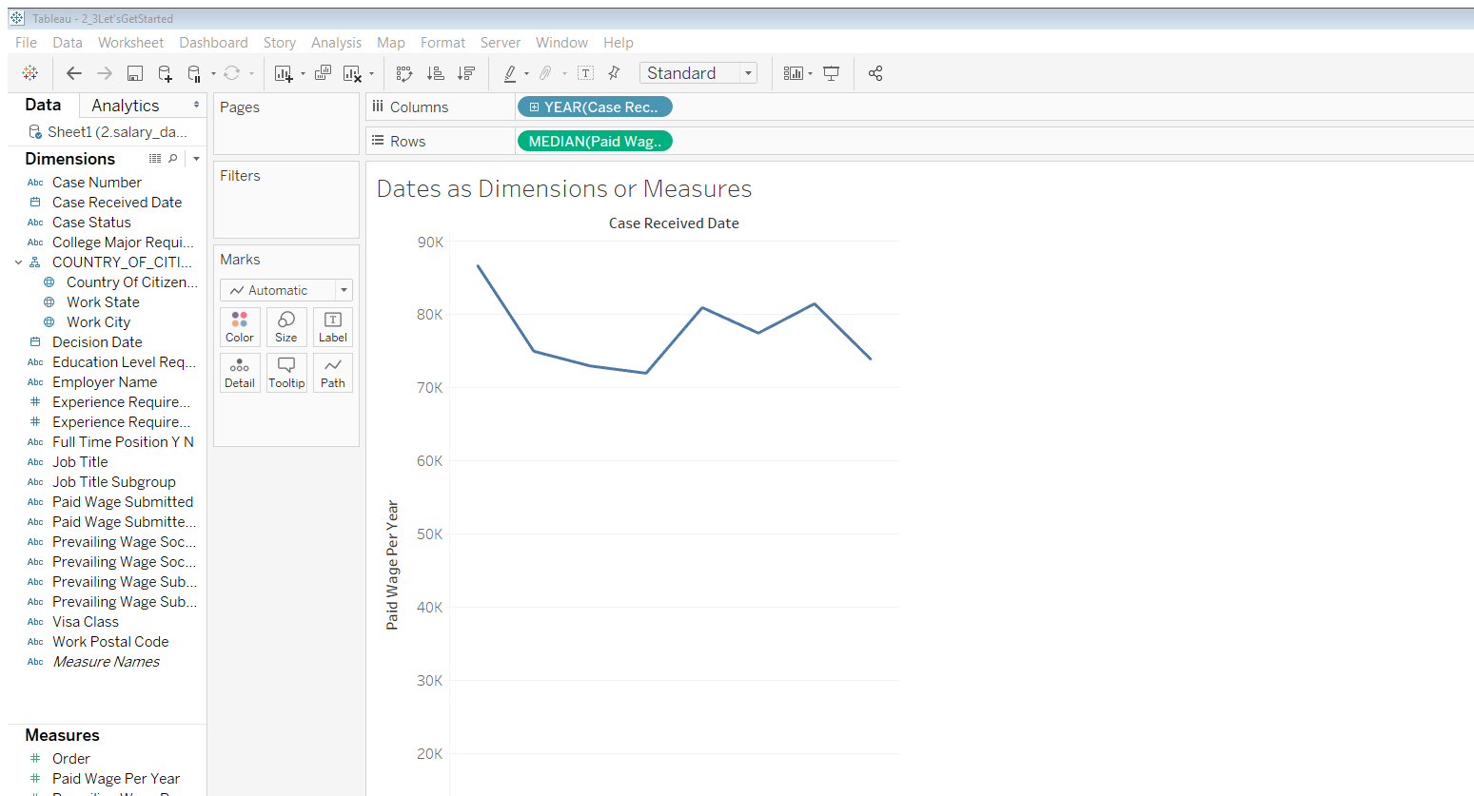

Years vs quarters and months

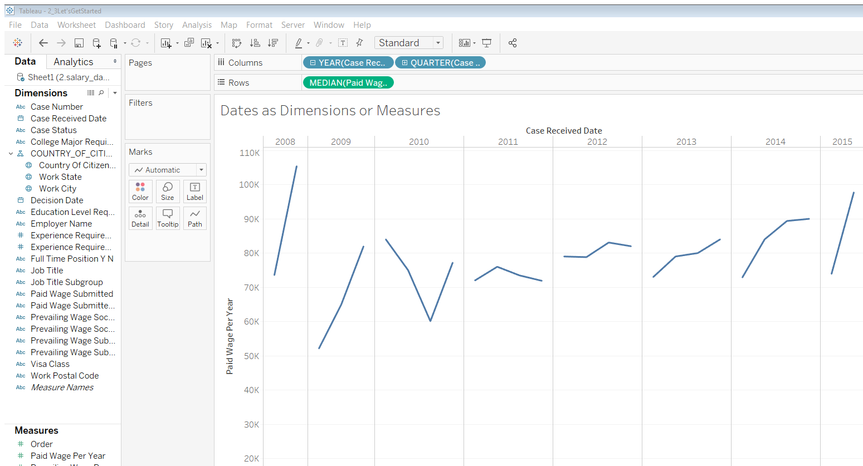

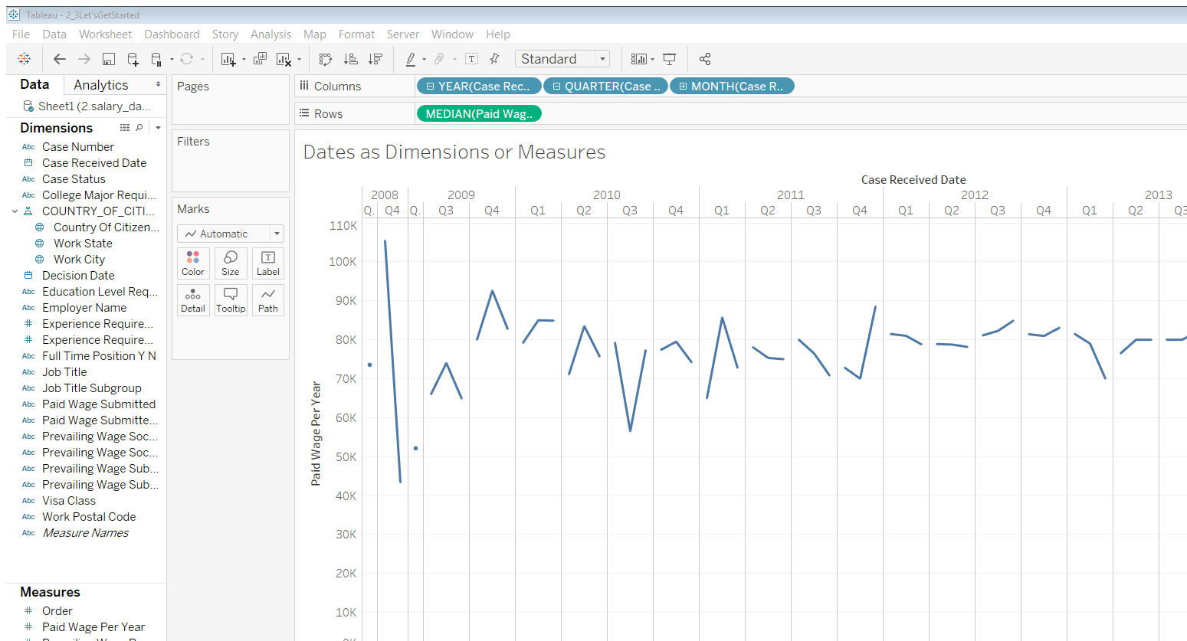

You can create/remove hierarchy

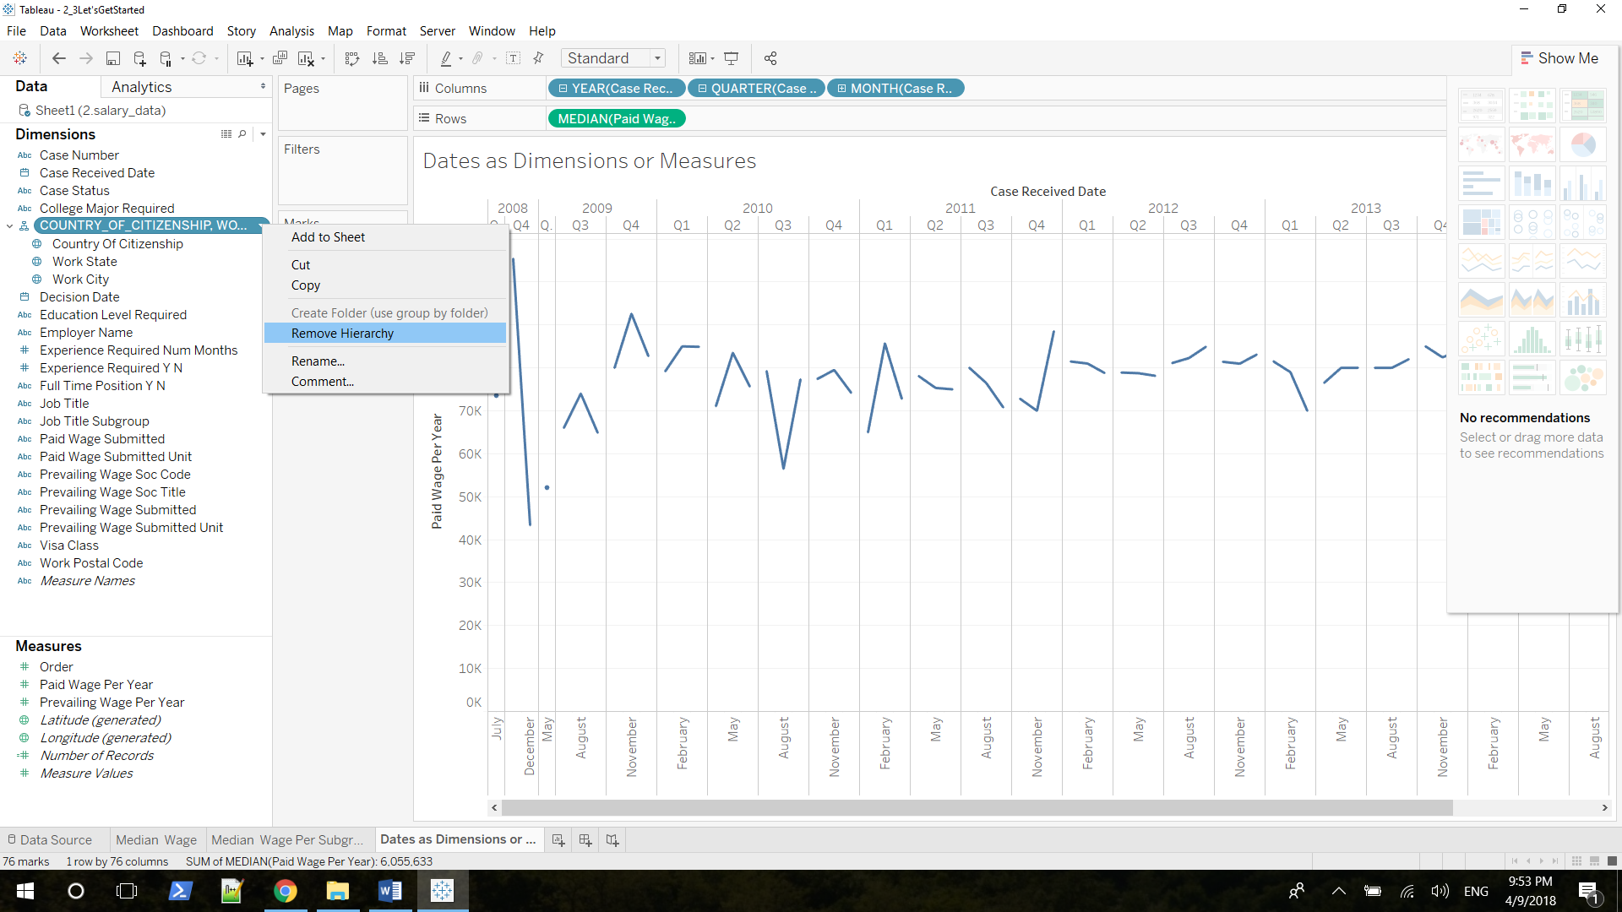

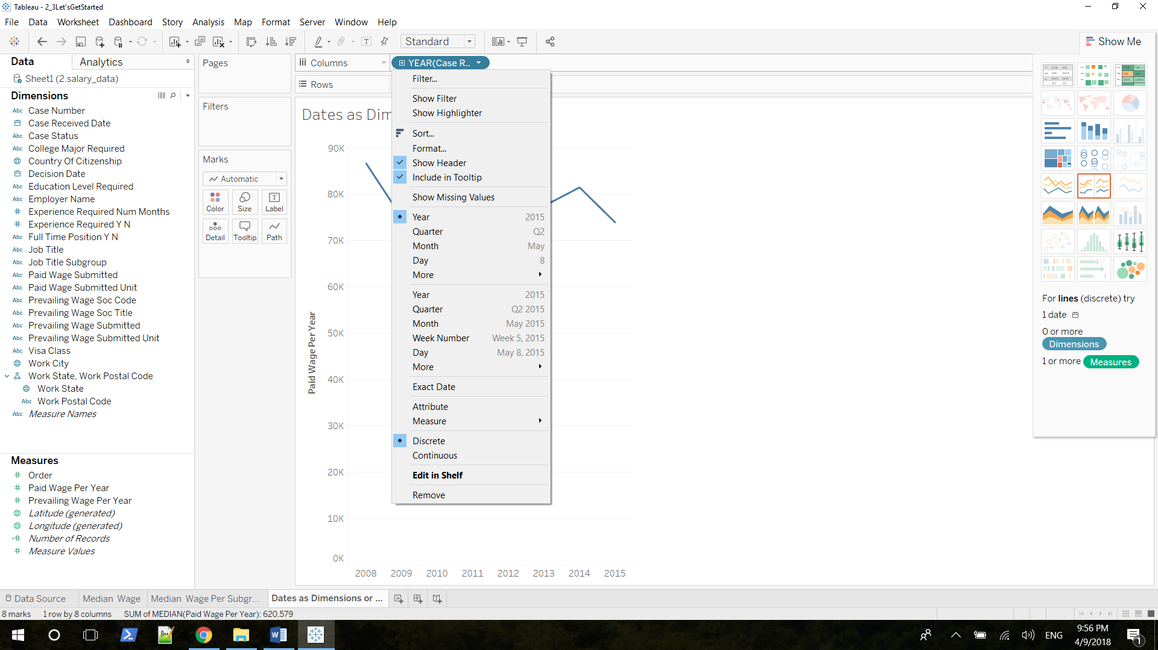

First block refers to all the instances when Tableau treats the data as a dimension, while the second treats date as a measure.

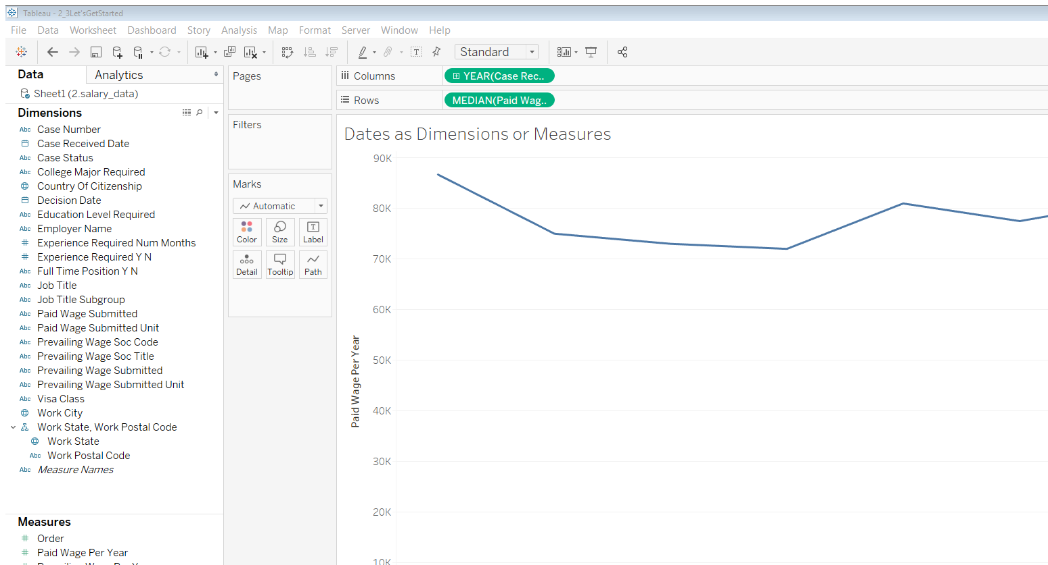

### 2.6.3 Analyzing Data-Related Salaries Over Time Using Date Hierarchies

Filter Case Received Date 1/1/2009

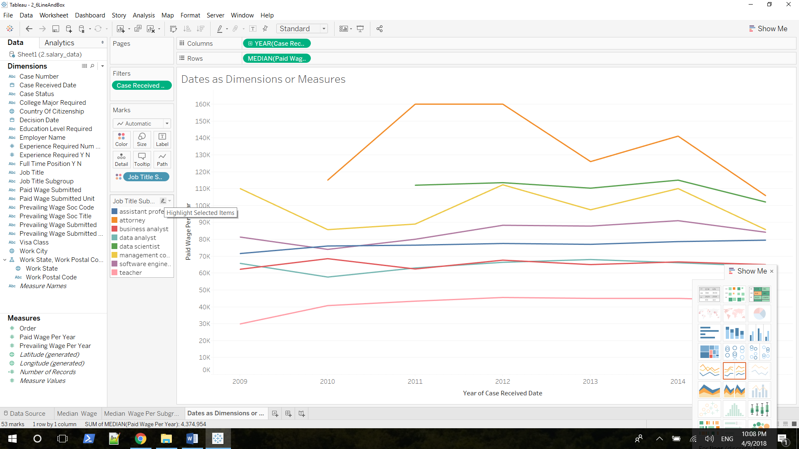

Uncheck Analysis => Aggregate Measures, Change date to measure, and choose Circle View from Show Me card

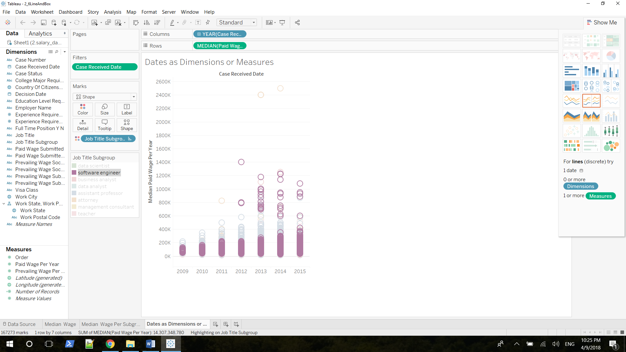

Software engineer looks very different. If you look at the very bottom values of these pink dots, it does look like their going down, but it also looks like the top values of each one of these blobs is going up. It's also obvious that there are a whole lot more outliers over time. So, there are a lot more individual instances of very high salaries for software engineers

Go back to line chart, you can see max goes higher and min goes lower

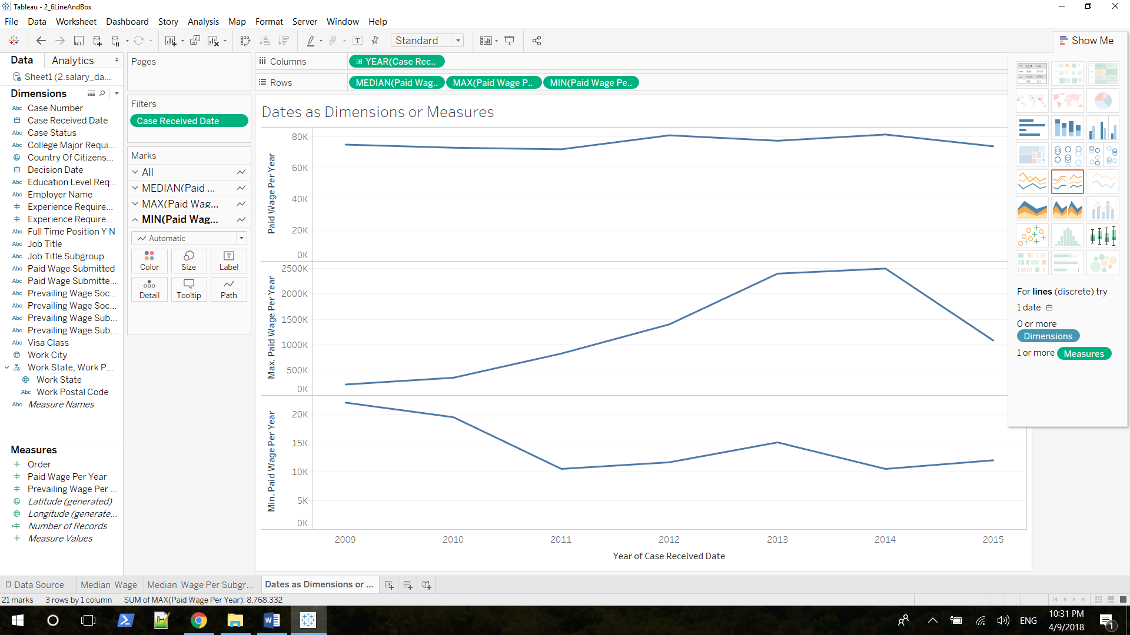

### 2.6.4 Analyzing Data-Related Salaries Over Time Using Trend Lines

Regression, best-fit line/ trend line

p-value should < 0.005 or 0.001

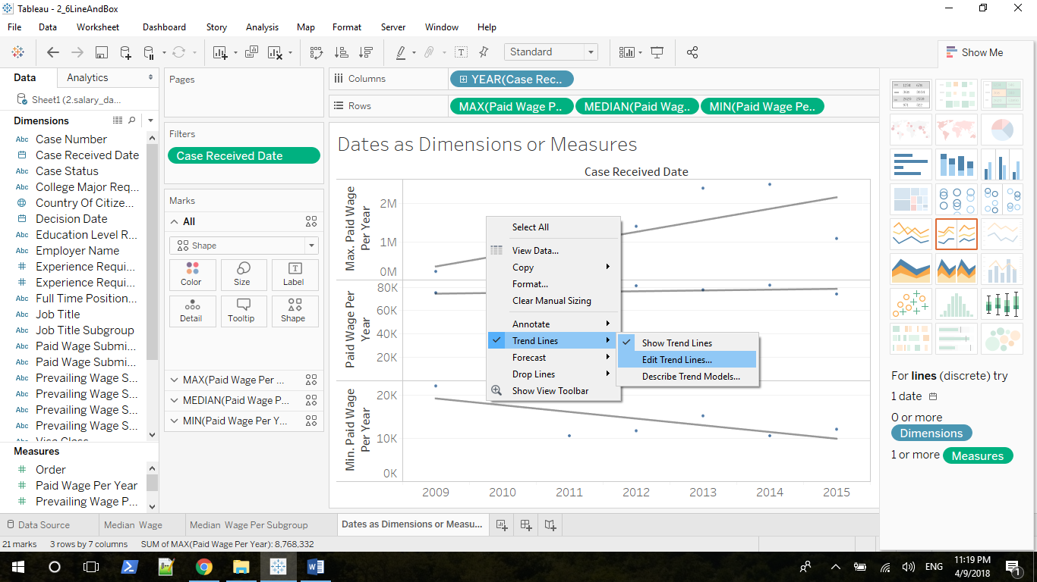

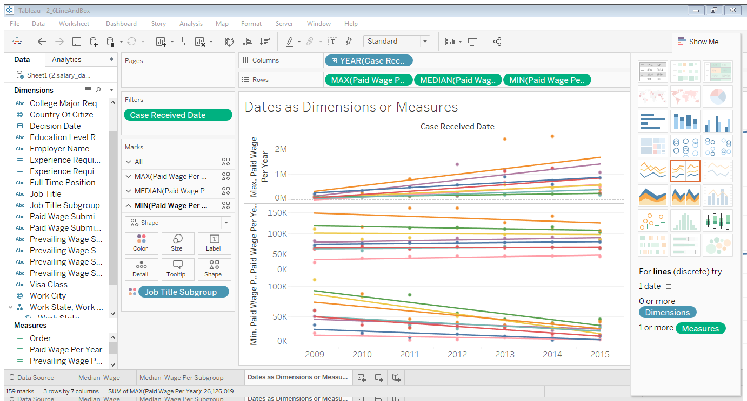

**Just look at the Data Scientist line**

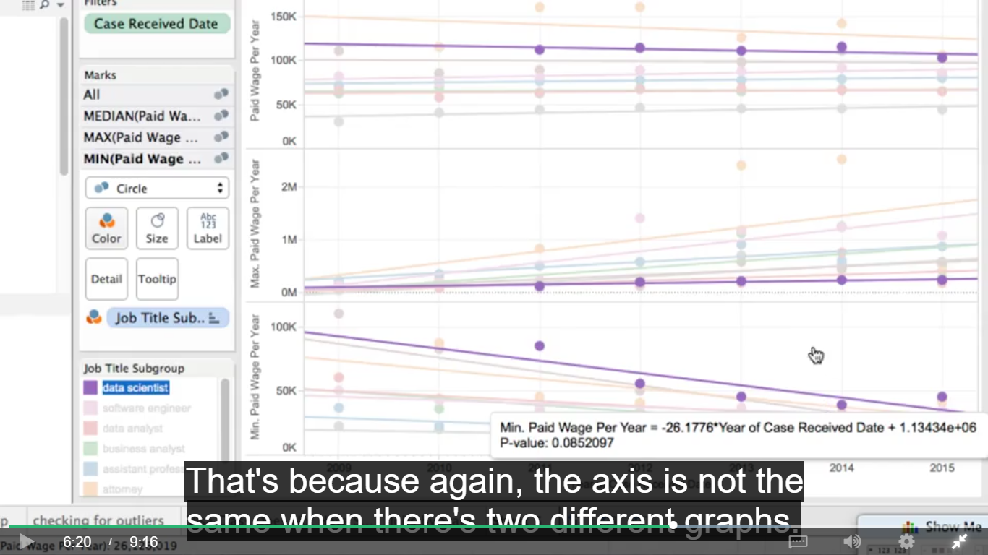

**Uncheck allow trend line per color will give you a trend line for all of the data aggregated together**

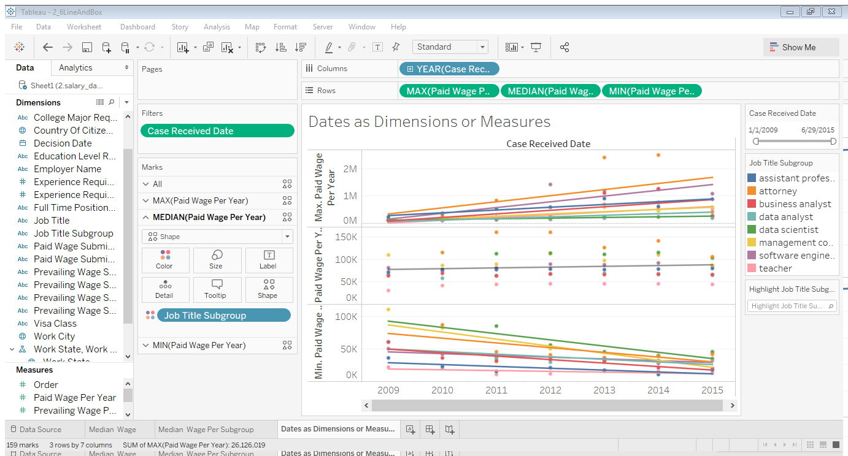

### 2.6.5 Analysing Data-Related Salaries Over Time Using Box Plots

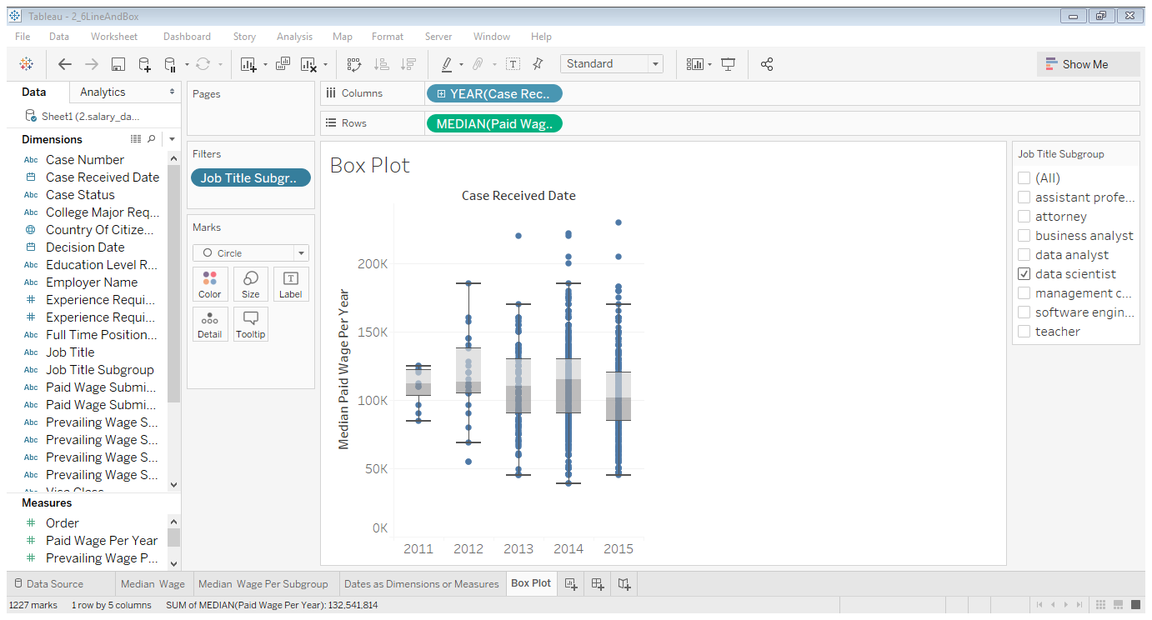  
can’t use color to divide into different boxes, not like trend line

Remember, this box shows you where 50% of your data is. 25% of your data is above this line, and 25% of your data is below this line. And so it's clear here, that over time, there are more and more salaries that have lower and lower values. There are also more and more salaries that have higher values. So this is showing us in an even stronger way than before, that although the median doesn't seem to be changing all that much, again remember, the median is this line here. It seems to be increasingly possible to get both a higher wage, and the lower wage than the median

Edit axis, cut out some outliers but to compare with data scientist more carefully

